

**ECE592 / MBA555**

**Product Innovation Lab**



**AI-ENABLED POLLEN COUNTING**

**Final Report**

**Team Members:**

Hrishikesh Mane

David Deininger

Stuti Garg

Luke Hale

Josine Mutuyimana

Jhair Williams

**December 9th, 2022**

**Table of Contents**

**1. EXECUTIVE SUMMARY** **5**

**2. PROJECT CHARTER** **6**

**3. VOICE OF THE CUSTOMER** **7**

3.1. Customer and User Analysis 7

Government Collection Sites 7

Individual Allergy Sufferers 8

Weather and Air Quality Forecasting Businesses 8

Medical Providers and Drug Manufacturers 9

Research Institutions 10

3.2. Experience Analysis 10

Observations 10

Interviews 12

Survey 13

**4. BUSINESS SITUATION ANALYSIS** **15**

4.1. Industry Analysis 15

Allergy Treatment Market 15

Weather Forecasting Market 15

Water and Air Quality Testing Market 16

4.2. Industry Factors 17

Porter’s Five Forces 17

PEST analysis 18

4.3. Stakeholders Analysis 19

4.4. Competitor Analysis 21

Executive Summary 21

Legacy Companies 22

Pollen Sense 23

Swisens 24

Hund 25

Pollen Datasets 26

Competitor Conclusions 27

4.5. SWOT Analysis 28

4.6. Business Risk Assessment 30

**5. PRODUCT DEVELOPMENT** **32**

5.1. Technology Analysis 32

5.2. Concept Idea Generation 33

5.3. Concept Development 34

Customer Derived Requirements 34

Technical Requirements Definition 36

Product Concepts 38

5.4. Study Models 41

Pollen Collection 41

Pollen Detection 42

Pollen Identification and Classification 42

Pollen Sensitivity 43

5.5. Concept Selection 43

Selection Summary 43

Selection Criteria Description 44

Relevant Competitor 45

5.6. Detailed Design 46

Product and Service Model 46

AI Pollen Counting Model 47

AI Pollen Classification Model 50

AI Pollen Forecast Model 52

Pollen Scout Hardware System 57

Pollen Base Hardware System 58

Pollen Data Cloud Application Framework 59

Pollen ID Phone App Software Framework 60

Technical Requirements Analysis 61

Bill of Materials and Assembly Estimates 63

5.7. Prototyping 64

Prototyping Round 1: Hardware Design 64

Prototyping Round 2: Computer Vision Enabled Counting 66

Prototyping Round 3, UV Fluorescence Testing 66

5.8. Engineering Risk Assessment 69

5.9. Final Design 71

Mobile Device Application 71

Pollen Scout Device 73

Pollen Base Device 75

**6. VALUE PROPOSITION AND BUSINESS MODEL** **77**

6.1. Business Narrative 77

6.2. Target Market Segments 78

6.3. Value Propositions 78

**7. GO-TO-MARKET LAUNCH STRATEGY** **79**

7.1. Go-to-market Approach 79

7.2. Pricing Strategy 81

7.3. Distribution Strategy 81

7.4. Marketing Tactics by Segment 82

7.5. Initial Roll-Out Strategy 83

**8. FINANCIAL ANALYSIS** **84**

8.1. Product Cost Analysis 84

Marketing and people costs 85

8.2. Profitability Analysis and Revenue Projections 85

**9. ADDITIONAL CONSIDERATIONS** **87**

9.1. Remaining Assessments 87

Engineering Testing and Evaluation 87

Business Planning 87

9.2. Key Competitor Reaction 88

**10. REFERENCES** **90**

**Appendix A: Customer Analysis** **92**

**Appendix B: Business Canvas and Industry Map** **95**

# 

# EXECUTIVE SUMMARY

Pollen is a ubiquitous material, created and utilized by seed bearing plant life around the

globe for the purpose of reproduction. It however can be a terrible nuisance for people with allergic sensitivities to these incredibly small particles. Forecasting pollen, much like the weather, can be an effective information tool permitting people to make informed decisions with regard to their health. Currently, pollen predictions and severity warnings in the United States are based on sparsely collected data which may be too late, too few, or completely inaccurate.

Pollen collection and analysis has remained the same for many decades; a few technologies have dominated the pollen counting service stations, relying heavily on highly trained technicians and very manual processes, with little to no automation (Ref. 5). In recent years, a couple companies such as PollenSense and Swisens have developed and deployed AI-enabled automated pollen counting systems, which seek to eliminate decades old technology through innovations in sensors and software. Even still, these devices are very costly and fail to resolve the primary issue with pollen information: the lack of localized data.

To resolve the pollen data void we are introducing the Pollen ID system aimed at providing a holistic solution to intermittent, inaccurate, and labor intensive pollen information. Our system encompasses the Pollen Scout, a low cost collection device designed for consumers, the Pollen Base, a more sensitive collection system targeting city centers, AI computing, and the Pollen ID application. Our goals are to provide affordable hardware to the consumer via the Pollen Scout device, provide AI-enabled data processing to classify pollen count and species, delivered to consumers via a Pollen ID mobile app, and enable unrivaled sensor deployment. Through the use of carefully selected sensor technologies and artificial intelligence enabled cloud computing solutions, our low-cost mass manufactured device, Pollen Scout, can be deployed at scale, providing a pollen counting accuracy per square mile that is unachievable with current industry practices.

Pollen Scout, the consumer hardware part of the Pollen ID system, is expected to be deployed in phases, first in Raleigh as a beta version, then expanding to many markets in the Southeastern United States using direct web sales. We estimate that our low cost system, targeted to the most allergy sensitive consumers, will turn a profit in year three of launch, with continued growth as we expand our markets to the North East, Midwest, and eventually to other countries around the world. We anticipate moving our channel of distribution to home improvement retailers, pharmacies, drug stores and trade shows as our targeted regions increase. Our Pollen ID application will initially be offered free to Pollen Scout purchasers, with an option to expand service to a greater population by subscription. Additionally, we intend to research channels to offer our collected, geospacially tagged pollen data to other businesses via contracts. Finally, we intend to pursue potential partnerships with allergy drug manufacturers for product sponsorship or as a complementary product to their offerings.

Overall, we believe the Pollen ID system is best suited to address a gap in the market of airborne pollen classification and counting by deploying a low cost collection device that takes advantage of crowd sourced collection to deliver inexpensive but accurate pollen information.

# 

# PROJECT CHARTER

Pollen ID’s mission is to revolutionize the collection and identification process of airborne pollen with the express purpose of increasing allergen forecasting accuracy, creating awareness, and assisting our customers in lowering their allergy treatment costs by affording users a better quality of life through personalized monitoring and alerts.

To achieve our mission, Pollen ID must develop products and services which provide ease of access to pollen data, above and beyond current offerings that require secondary equipment, long procedures, and specialized knowledge of how to identify pollen taxa. Pollen ID’s three core pillars of innovation to achieve this goal are: creation of effective hardware, coupled with innovative software, at an unprecedented deployment level.

* Effective Hardware: Develop a new pollen counting device, driven by AI systems to increase counting speed, better categorization, lower error rates, with lower maintenance requirements.
* Innovative Software: Development of AI models capable of properly identifying and correlating pollen taxa, separating false positives from other materials.
* Widespread Deployment: Pollen forecasting thus far has suffered from the lack of consistent and reliable data sources. By offering a direct to consumer product, local users gain immediate benefit from pollen reporting; and as the network of devices grows, so does the availability of concrete data to support accurate pollen forecasting.

# 

# VOICE OF THE CUSTOMER

## Customer and User Analysis

Customers in the airborne pollen allergy space vary widely from the purchase and installment of collection hardware by various entities, to the ingesting of pollen collection data by forecasting companies, the individual allergy sufferer, and the medical professionals treating allergy symptoms. Each customer has different individual needs but all demonstrate the need for more accurate and timely pollen data collection to make decisions related to health. Through professional interviews, surveys and research our team has identified the needs of several stakeholders.

### Government Collection Sites

* **Description**

This customer set represents a business to business relationship where government agencies operate pollen collection sites to inform public health. Examples of these sites include the Reedy Creek Road Air Quality Laboratory in Raleigh, NC, operated by the North Carolina Department of Environmental Quality.

* **Core Use and Needs**

Government agencies which collect and count pollen, utilize the data in providing pollen advisories for travelers and local residents within the area. Of particular note, pollen counting and reporting is much more prevalent In European countries. Government entities report pollen on a daily basis for pollen levels collected the day before. Pollen is analyzed by hand though labor intensive dying and observation through traditional microscopes. Collection and classification is typically done by air quality analysts that have other duties as well. Government collection and analysis needs additional collection locations with automated classification that can provide real time pollen counts for release to residents. .

* **Unmet Expectations**

As reported by correspondents (Ref. 2 and 3), individual pollen allergy sufferers inquire about pollen count heavily during high pollen seasons. Both government and news agencies do not perform seasonal studies, nor do they have a reasonable dataset to perform predictive analyses used in forecasting.

In addition to pollen forecasting, pollen counting centers are few and far between, with an average public counting facility of one per state in the US (Ref. 5). Because pollen is best analyzed as a local phenomenon, the lack of pollen collection sites prevents accurate pollen forecasting in the US, which impacts overall allergy prediction fidelity. Derived conclusions are that the industry utilizes decades old technology and manual counting methods which take hours to perform at high cost. Additionally, existing industry prediction models use data which is limited by the lack of collection sites to generate pollen forecasts with low geographical accuracy.

### Individual Allergy Sufferers

* **Description**

The ultimate end user of pollen count information is the individual allergy sufferer. According to the Asthma and Allergy Foundation of America (AAFA) over 50 million people suffer from allergies in the United States. 24 million of those people suffer from seasonal allergies brought on by airborne pollen. The AAFA states that allergies are the sixth leading cause for chronic illness in the United States, costing $3-4 Billion in annual health care expenses.

* **Core Use and Needs**

Allergy sufferers use pollen data to make preventative medical decisions relating to allergy symptoms. A study published in the Current Medical Research and Opinion Journal titled “Real-world evidence costs of allergic rhinitis and allergy immunotherapy in the commercially insured United States population” found that patients who took therapeutic measures to deal with allergic symptoms had less severe reactions over time and saved $1,000 to $9,000 in annual medical costs. Pollen information is important in initiating allergy therapeutics to decrease reaction severity.

* **Unmet Expectations**

Currently, the pollen information provided to allergy sufferers is limited in locational accuracy and timeliness. Pollen reported by the local news or government websites is at least 24 hours old and based on pollen collected at that specific collection site. Since pollen has a localized impact, pollen species and count can drastically differ over periods of geography and in relation to weather phenomenon. Furthermore, allergy prediction tools offered through mobile applications are limited by the same lack of pollen data or the data is discarded altogether. In a recent interview with former The Weather Company (TWC) project manager, Misha Sulpovar, the allergy prediction tool utilized on the TWC platform eliminated pollen count data due to the unreliability of collection times and locations. The lack of accurate pollen data has led to inaccurate pollen forecasting and has limited the usefulness of airborne pollen data in individual therapeutic decision making.

### Weather and Air Quality Forecasting Businesses

* **Description**

Companies such as AccuWeather and TWC are market leaders in weather forecasting, in a market that sees an annual revenue of $16.6 Billion and 4% CAGR. These companies and others provide services in modeling, measurement, publishing, and data management. Their services include real-time air quality data that they gather from a range of resources. These companies represent a business to business customer relationship for Pollen ID.

* **Core Use and Needs**

Weather forecasting companies are in a constant need for more relevant, real-time information to provide to their customer base. Customer demand for these services to make real-time decisions has increased significantly, causing these companies to find new ways to differentiate themselves with better quality content. As an example, AccuWeather has recently acquired Plume Labs to bolster their air quality services. Additionally, weather forecasting companies are competing to take advantage of the increase in mobile devices with tailored applications that offer forecasting services. TWC recently partnered with Samsung to be the native weather application on all of their mobile devices. As stated previously, pollen data has been considered unreliable for use in many prediction models. Weather forecasting companies need more timely and accurate pollen data to incorporate into their predictive models to help differentiate their products from the saturated market’s competitors.

* **Unmet Expectations**

As with government and individual users, availability of airborne pollen information is limited to the number of pollen collection sites. As stated by Misha Sulpovar, this has caused companies such as TWC to discard pollen count in their predictive models. The results of this, as he conceded, is that the prediction accuracy is low (r-squared value of .3), which limits the tool to only offering a “High, Medium, Low” color coded output. Without accurate pollen data, collected within the geographic prediction area, allergy models prove only to serve as gimmicky efforts to produce differentiation and ancillary tools for end users.

### Medical Providers and Drug Manufacturers

* **Description**

Medical professionals assist individuals in diagnosing and treating allergies by offering remedial actions, prescribing drugs, or recommending OTC solutions. These consist of primary medical providers to allergy sufferers and pharmaceutical companies that create and sell allergy medicines. The customer relationship with these entities and Pollen ID would be business to business, selling access to pollen data and/or pollen collection hardware to medical practices or medical conglomerates. Additionally, product sponsorship or partnership with pharmaceutical companies may be an option.

* **Core Use and Needs**

As mentioned in local news reports and broadcasting (Ref. 4), medical providers utilize pollen count data to understand the high seasonal allergy seasons in order to better treat patients. Details of the airborne pollen exposure to patients can help providers discern allergic reactions that may be caused by higher numbers of known allergen causing pollen types. Additionally, some studies have concluded that pollen related allergies have been found to cross over to certain food allergies, known as Pollen Food Allergy Syndrome (PFAS). Providers that have access to pollen data may be able to better diagnose food allergies in patients as well.

Pharmaceutical companies that create and distribute allergy medicines may use pollen data to drive their marketing timelines, targeting certain product releases or advertisements around predicted windows of time as a way for customers to build up resistance before heavy seasons. Additionally, pollen data may better serve drug companies in medicine formulation to target certain kinds of allergies based on pollen species.

The need for this customer base is additional pollen data, which means additional collection sites that can classify and count airborne pollen in local environments. Current pollen data is limited by collection and thus is not impactful to treatment and research.

* **Unmet Expectations**

Providers interviewed by WRAL recognize seasonal patterns, but do not have any predictive measurement tools (Ref. 4). The unmet expectation remains the same for drug companies. The lack of this information inhibits advancements in therapeutic measures both providers and pharmaceutical companies could take to combat seasonal allergies.

### Research Institutions

* **Description**

The broad veil of research by institutions involved in pollen counting, classification, and identification has widespread applications. This customer category is quite broad with varying needs and use cases.

* **Core Use and Needs**

Innumerable use cases. Available pollen data has been used to generate forecast algorithms, correlate extended pollen seasons with global warming, identify trends in flowering plants, etc.

* **Unmet Expectations**

As with every other group, and as noted in research papers, the availability of pollen data is sparse and lacking. Researchers specifically need much more granular information on pollen species identification to perform a wide breadth of scientific studies.

## Experience Analysis

### Observations

*NC Division of Air Quality Pollen Collection Site*

Our team had the opportunity to visit the only pollen counting lab in the region run by the NC Division of Air Quality (DAQ) at Reedy Creek Road, to interview and observe the pollen counting process. This site uses a rotorod collection device, priced between $5 - $10K, with high-cost consumable precision glass prepared with grease to collect samples from the air. It takes a considerable amount of time and effort to prepare the equipment and to manually count the pollen.

|  |  |  |
| --- | --- | --- |

Samples are taken every 10 minutes over a 24-hour period, 4 days a week between March to October. Anyone can obtain certification to count pollen, however it requires several years of experience to efficiently identify 40+ pollen types. Pollen counting can become tedious when grains become heavily stacked on top of each other, requiring the analyst to count several layers in magnification. Devices with 400X magnification are needed to identify certain pollen, their shapes and roughness, or to identify damaged pollen structures. In low pollen seasons it can take 1-2 hours to accurately count a daily pollen collection while it may take up to 8 hours to count during high pollen seasons. The counting process depends on an experienced analyst who consults a catalog that houses hundreds of images of pollen types and conditions to help ID pollen. Times drastically increase if a less experienced analyst is on duty. The Reedy Road site only has one primary analyst and one backup, with pollen counting as only a part of their duties. Due to the time it takes for pollen counting during the high seasons, the analyst only spends 2-3 hours counting and extrapolates the rest of data to give a pollen estimate.

|  |  |  |
| --- | --- | --- |

Pollen collected on the rotorod device can be greatly affected by surrounding vegetation. At the Reedy Road site, a local garden growing vegetation not native to that location is responsible for depositing “outlier” pollen grains on the collection sample. Given that the results of the pollen sampling are used across the region, where the local garden is not located, the non-native pollen can impact the overall accuracy of the pollen count. Once collected and analyzed, the detailed report containing over 40 pollen types, is documented and retained on physical paper. Data from a subset of pollen types (Grass, Tree, Weed) is then manually entered into an automated electronic reporting system, which classifies pollen counts as low, medium, or high to subscribers, Media, Doctors, or other researchers. The only digital record of pollen collected in the Piedmont region of NC is a simple count of grass, tree, and weed pollen per day.

### Interviews

*Misha Sulpovar, former head of AI development at The Weather Company*

Our team had the opportunity to interview Misha Sulpovar, the former AI development head at The Weather Company, which produced an allergy prediction tool as part of the TWC application. His team experimented with building an AI algorithm that would best predict allergic conditions due to weather. TWC used recently completed IBM MarketScan data collected from 2014 to 2017 highlighting allergy medicine purchase and insurance claims for doctors visits, as well as pollen count data.

During their iterative process, they found that the pollen data did not produce a statistical signal in their analysis. This meant that there was no statistical correlation of pollen count to other factors they looked at. Misha outlined three major reasons they found this result. First, pollen count data was not localized and therefore could not be correlated with other weather data. Second, pollen collection stations were low tech and did not publish detailed pollen data such as species. Third, pollen counts that were collected were not always published. To quote Misha, “When Bill, the pollen guy is out sick, we don’t get a pollen count for that day”.

The model that TWC produced was tested across all data sets, primarily consisting of buying behaviors of OTC allergy medicines, health seeking behaviors, and insurance claims. The final result was an r-square of .3, meaning approximately 30% of the predicted outcome can be attributed to the model. This low prediction score caused TWC to market the model as a broad red, yellow, green output prediction for customers.

While Misha was proud of the work they did at TWC, he acknowledged that the predictive factors were subject to inaccuracies but felt they were the best data to be used at the time. He emphatically stated that a more detailed and robust pollen data set would have a positive impact on allergy predictions. Additionally, he stated that localized pollen data combined with user medical data inputs would yield a much better solution for allergy sufferers.

*Informal Allergy Interview*

Informal Interviews were conducted at random of more than 16 individuals with a focus on 3 areas:

1. Do you get/check pollen data?
2. What do you do with it – how is it useful to you?
3. Do you care about the different types?

Initial responses indicated that people did give great importance to knowing the type of pollen in the air during each season and cared more about when the season may start so they can take steps to avoid or to medicate. Most individuals indicated they do not check pollen levels beyond what was provided by a weather forecast or a weather app. An NC native indicated that if pollen counts were reported as high, it would not convince them to stay inside or change plans since it's not something they can control. While these individuals self- identified as having allergic reactions to pollen, they stated that their reactions were not severe. Additionally, some users indicated pollen data will only be useful to them if it gave advance notice about the start of the season so they can start medicating up to 2 weeks beforehand to build up a resistance. It was highlighted by the NCDEQ pollen analyst that 1,700 users follow their twitter handle for updates on pollen counts. This analyst also said that the most common question they receive at their lab is from individuals asking “When can I power wash my deck?” during the high pine tree pollen season of spring.

### Survey

*Pollen Allergy Survey.*

To drill into elements of the feedback received we have conducted a 10 question survey with individuals to help validate some hypotheses we have formed from our initial research. The survey would help validate preferences of those who had less severe pollen related symptoms of pollen vs those who had more severe symptoms. It would also aim to address consumer perception of the current state and willingness to purchase pollen products and services.

Questions:

1. How are you affected by seasonal pollen?
2. How often do you check pollen count or forecasts?
3. Where do you typically get your pollen count information?
4. How important is it for you to know the types of pollen (grass, trees, or weeds) in the air during a season?
5. You indicated it's important to know the different types of pollen during a season, can you elaborate why?
6. How do you use pollen count information for yourself or others?
7. What do you think is the accuracy level of the pollen count data you receive today?
8. How important is it to you to get more accurate local pollen data?
9. You indicated it was important to get more accurate local pollen data. Can you elaborate why?
10. Would you pay for highly localized pollen count data (e.g. around your home)

Over the span of 2 weeks 75 possible consumers responded. 68% or respondents check pollen data when the season starts or daily based on the severity of their symptoms. 100% of the respondents who were impacted by pollen leverage the data to avoid or treat their symptoms. Only 9% of those who use pollen data had any high degree of confidence in the data they received today and over 86% place a high importance on getting accurate data. The primary method for consumers to get data was through the news or an app on their mobile device.

To summarize, allergy sufferers are interested in the accuracy of the airborne pollen count but are also uneducated on the actual accuracy of the data they receive. Second, allergy sufferers check pollen data daily or weekly to aid in making health treatment decisions. And finally, approximately 46% of allergy sufferers would pay $100 or less for a pollen application.

*See Appendix A: Customer Analysis for detailed report output.*

# 

# BUSINESS SITUATION ANALYSIS

## Industry Analysis

There are three markets that have cross over applications with our pollen data project. These markets are Allergy Treatment, Weather Forecasting, and Water and Air Testing Services.

### Allergy Treatment Market

The global allergy treatment market was valued at 19.07 Billion USD in 2021.This market is expected to grow exponentially at a rate of 2.87% in the forecast period of 2021 to 2028. Among those who are suffering from pollen allergies, there is a rise in the number of children, which is also escalating the growth of the pollen allergies market. As per thenAsthma and Allergy Foundation of America (AAFA) more than 25 million allergies are caused due to increased pollen counts. Most allergy medicine is prescribed by medical providers based on allergic reaction and availability. While increased research and development of allergy medicines will increase revenues, it will also put pressure on increased profits. This market may benefit from detailed pollen data in the development and prescription of therapeutics.

The major factors that are expected to boost the allergy treatment market growth from 2021 to 2028 include the rapid urbanization in developed countries and the increase in impacts of climate change.

Regions that are projected to dominate the pollen allergy market are North America and Europe. Both regions have developed pharmaceutical industries around treating allergic reactions and show an increase in the awareness levels about allergy and allergy diagnostics. Additionally, North America is reporting a rise in allergy related respiratory conditions, such as asthma, which is irritated by pollen allergies.

### Weather Forecasting Market

The weather forecasting market sees $16.6 billion in annual revenue, with a continued projected growth of 4% annually. This market breaks into four primary segments: Operations and Modeling, Measurement Services, Publishing, and Data Management. Additionally, Health and Society Services makes up 18% of the market revenues at $3 billion.

The weather forecasting market is highly saturated with over 45,000 businesses and with two lead companies (AccuWeather and TWC) comprising only 3% of the market share. Current market trends surround the demand for more real-time forecast data for consumers to make decisions. Low market concentration drives company differentiation goals, such as increased data and more accurate forecasting models. Recently AccuWeather acquired Plume Labs to increase their air quality forecasts and address an emerging market need. As discussed previously, TWC generated an allergy prediction tool that excluded pollen data due to its unreliability.

Another driver in this market is the growth of portable electronic devices. As mobile internet connections increase, weather forecasting companies seek to optimize forecasting tools for portable applications. Recently TWC entered into a partnership with Samsung to have the TWC application as the native weather app on all Samsung devices.

There is opportunity within the health and society services segment of weather forecasting as a link between climate change and heath. Customizable forecasts for individuals based on their location are the newest innovations within this market. Allergy prediction and forecasting can provide a growth opportunity for weather forecasting companies as well as become a differentiator in the market. These opportunities make pollen data a valuable commodity to increase forecast accuracies.

### **Water and Air Quality Testing Market**

The water and air quality testing market has an annual revenue of $6.7 billion and is growing at an annual rate of 2.5%. The market is segmented into outdoor and indoor testing. Pollen falls into the indoor air quality testing segment along with fine particles, molds, and carbon monoxide. The air quality testing segment is 34% of the total market and yields $2.3 billion annually.

Within the market, consumer sales constitutes 19% of market revenue, which comprises individual households, electronics, medical devices, and retail. The public segment of the market constitutes 7% of total market revenue and comprises quality control, health and safety measurements. The largest margin of public air quality testing is located in the Southeast United States.

The market concentration of water and air quality testing is low, with the top two competitors holding a total of 8% of the total market share. Companies in this market compete mainly on breadth of testing abilities, with larger market shareholders possessing the ability to test more areas. Other areas of competition are in speed of result delivery and a growing number of businesses forming in-house labs to conduct testing. Pollen Scout collection and analysis sensors fit within this market and are differentiated by lower cost and crowd sourced data analysis.

## 

## Industry Factors

### Porter’s Five Forces

Intensity of Rivals: LOW. The number of competitors in the pollen collection and analysis industry is low currently, with a mix between standard collection products by companies like Aerobiology Research and more automated devices like the ones offered by PollenSense. Additionally, lab analysis of pollen offers many competitors that conduct pollen analysis as one of numerous services. The divergence of product type offers some differentiation in the market. The size of the pollen allergy market is big enough that there is capacity for competitors to exist without much downward pressure on prices, i.e. no current price wars. This may change as new entrants enter the market offering new technologies and products.

Supplier Bargaining Power: MEDIUM. The number of suppliers in the pollen collection and analysis market are low and diversified. Bargaining power is dependent on the type of equipment required. Most analog products or analysis labs require components that have a high level of substitutes and therefore remove supplier bargaining power. This may change based on the level of specialized equipment required for the new technologies on the market. Suppliers are more limited with these more scientific components and thus have a higher ability to capture profits created in the value chain. Given the diversity of the pollen collection devices and analysis labs in the market, the overall power rating is a MEDIUM.

Buyer Bargaining Power: MEDIUM. Buyers in the pollen collection and analysis market are typically government, scientific organizations, or agriculturists. Current market offerings vary in technology which gives buyers some ability to choose alternatives. This gives them some bargaining power when shopping for collection and analysis devices or pollen analysis services. It also increases the switching costs of the buyer if they cannot negotiate reasonable purchase prices for equipment they have already in use, often requiring a switch to an entirely new technology. Buyers who are seeking pollen analysis have more lab analysis companies to choose from with little to no switching cost. Overall buyer bargaining power averages out to MEDIUM

Threat of Entry: HIGH. The pollen collection and analysis market is high based on the limited number of firms in the market and the opportunity for product differentiation. Retaliation by existing firms in the market is low at this time due to the capacity of the market, however this could shift as new entrants begin to capitalize on growth areas. Research and development of pollen capture and analytic products is lowering as technologies such as AI and micro-imaging become more prevalent, however still impose a small barrier for entry. As technology develops in other markets, the horizontal movement to pollen counting and classifying by established companies will draw more entrants.

Threat of Substitutes: MEDIUM. The problem that the pollen collection and analysis market is trying to solve yields many different types of solutions based on developing technologies. For this reason, substitutes in the market currently exist and will continue to increase. The price elasticity of the buyer, however, is somewhat rigid given the current customer make-up. New targeted buyer populations may increase this elasticity and entice additional substitute products. Switching costs are dependent on the sector of the market and the type of product utilized. Pollen classification analysis has a lower switching cost and is thus open for more substitutes, while a shift to new technologies in product collection devices will increase switching costs.

### PEST analysis

Political: Global governments, primarily in Europe and North America report pollen count as a public service to the community as part of air quality and public health. Guidelines and priority of effort are dependent on regions and individual governments, with higher interest and effort being applied in Europe on average. Pollen count is also a factor in understanding agricultural industry health and yield, which are areas governments may regulate and report on.

Economic: In the United States, medical costs due to allergic reactions to pollen are in excess of $3B annually and impact over 60 million people. Half of this cost is linked to prescription medication. Allergic reactions also add in opportunity cost with loss of working hours. In agriculture, the fruit and tree nut market is expected to reach $1.2T by 2025, and relies heavily on bee pollination. Pollen classification, count, and forecasting is important to lessening medical treatment costs of chronic illness caused by pollen allergies as well as aiding in the continued growth in agriculture.

Social: Pollen allergies impact over 60 million people in the United States alone, expanding into the hundreds of millions globally. These reactions inhibit active participation by people during times of high pollen, impacting their personal wellbeing. A lack of accurate and local pollen collection stations offer little support to the planning of daily activities for severely allergic people. Local news outlets and other media broadcast daily pollen counts across multiple platforms to help inform the populations they serve but are limited to the data provided.

Technological: Pollen collection and analysis has remained the same for over two decades using standard analog collection devices and human eye analysis under a microscope. New developments in AI have decreased the time and effort required to classify pollen while advancements in imaging technologies have provided alternatives to the physical capture of pollen grains on a sticky substance. These developments are becoming cheaper and miniaturized and make practical application more possible.

## 

## Stakeholders Analysis

We have identified key stakeholders through research that are deemed to be relevant to our solution design and market strategy:

**Individual allergy sufferers and asthmatics**: It's estimated 30% of the world population suffers from seasonal allergies caused by pollen. In the United States, 25 million people have severe allergies connected to pollen. Survey data suggests that these populations are in search of more accurate forecast information. Allergy sufferers can use this data to begin therapeutic treatments ahead of peak pollen seasons and limit health impacts.

**Pollen Lab Analysts and Counters:** will provide key insights into various tools, systems, counting processes and evaluating AI driven results vs. automated systems. These experts will serve as accuracy validators of future pollen collection products.

**Governments** (often local), **Institutions or Non-Profits:** (e.g., NIEHS, NAB, AAFA) provide information based on research, reporting and education on pollen with limited resources or source information from private companies. Local governments that seek to provide better airborne pollen data to the public will be customers and end users in the value chain. Additionally, government host collection sites may become enablers to the Pollen ID system by utilizing hub systems for more detailed pollen classification.

**Weather Forecasting Services:** are in constant competition to provide timely and accurate air quality forecasts to consumers. Larger companies like TWC have created complex AI models to predict allergy impacts but lack precise pollen data to make their predictions valuable. These companies can be both customers of pollen data as well as partners for collection hardware distribution and AI forecast model support.

**Pharmaceutical Companies** like Johnson and Johnson, producers of Zyrtec, develop drugs for over the counter consumption to combat allergies. Forecasting pollen allergens weeks ahead of individual allergy sufferer impact will benefit drug marketing and supply chain management. Additionally, more localized pollen data may benefit future drug development for tailored allergy medicines. Pharma companies can be customers of pollen data and potential partners for hardware distribution and sponsorship.

**Medical Providers** that diagnose and treat allergic symptoms due to pollen have a vested interest in accurate pollen forecasts. Localized pollen classification information better aids doctors in pinpointing allergens for their patients and helps mitigate complications through appropriate therapeutic treatment plans. Additionally, pollen predictions will enable medical providers to be more proactive in their patient’s health by recognizing potential health impacts in advance of onset. These professionals can serve as both advisors to product development as well as customers of pollen data.

**Insurance Companies** are significantly impacted by allergic reactions annually. Accurate forecasts of pollen events will allow these companies to best position themselves for increased hospitalization and treatment activities by the insured. This stakeholder may also become a potential partner in offering Pollen Scout as a preventative device, as part of plan coverage.

**Agriculture** is heavily dependent on pollination each year. Studies have shown that accurate tracking of pollen data can help predict future crop yield, helping farmers make more precise financial decisions each season.

## 

## Competitor Analysis

### Executive Summary

Competitors in this space are very minimal at the present moment with a few emerging competitors new to the market. Historically, a few technologies have dominated the pollen counting scene for decades at a time, with slow waves of integration and fading as the industry adopted newer methods and technologies (Ref. 5). These devices were the Durham, Burkard, and Rotorod samplers. The common vane of operation for these older devices was the need to collect the sample on a prepared apparatus, staining, and then perform the inspection at a microscope through manual counting process where a trained technician would need to identify the individual pollen particles. However, new entrants such as the PollenSense and Swisens devices have evolved into partial or fully automated systems, which seek to eliminate decades old technology through innovations in sensors and software to perform automated capture, analysis, and reporting.

In the table below, comparison analysis was performed looking at each solution from perceived data collected. Note that a (?) means that no data could be attained, and a best guess may have been presented.

|  | **Product Offering Comparison** | | | |
| --- | --- | --- | --- | --- |
| **Attribute** | **Legacy** | **PollenSense** | **Swisens** | **Hund Pomo** |
| **Initial Sampler Cost** | $$  ($5k - $10k) | $$  ($3k-$8k) | $$$  ($14k-$20k) | $$$$  (~$150k) |
| **Other Initial Costs** | Standing Fixture &  Microscope | Standing Fixture | Utility Install ($$) | Utility Install ($$) |
| **Recurring Cost** | $  (glass slides) | $  (filter tape) | $ (?) | $$  (rotary slides) |
| **Maintenance** | Daily | Monthly | Yearly (?) | Yearly (?) |
| **Taxa Identification** | Training | Auto (fixed cost per) | Auto (fixed cost per) | Auto (repository) |
| **Size** | Small | Small | Large | Very large |
| **Portability** | Portable | Portable-”ish” | Fixed | Fixed |
| **Speed** | 2-24 hours | Real Time | Real Time | Real Time |
| **Accuracy** | Training Dependent, as high as 99% | >90%  (claimed) | >95%  (claimed) | >90% (claimed)  ~85%  (tested) |
| **Detection Method** | Bright Field Microscopy | Dark Field Microscopy | Laser Holography and UV Fluorescence | Dark Field Microscopy and Laser Holography (?) |
| **Ease of Use** | Extensive Training Required | Plug and Play | Plug and Play | Plug and Play |
| **Adoption** | Legacy  (Everywhere) | ? | ? | ? |
| **Connectivity** | None | WiFi Required | WiFi Required | WiFi Required |
| **Reporting** | Manual | Auto | Auto | Auto |
| **Forecasting** | No | Yes | Yes | Yes |

A brief synopsis of each competitor, and their capabilities is described in the various sections below.

### Legacy Companies

**Company Overview**

A few small companies build and market these devices. As compared to the new competition, these companies do not have a large online presence, rather relying on established relationships to support their customers' needs. For illustrative purposes, some of the well known legacy devices are shown below.

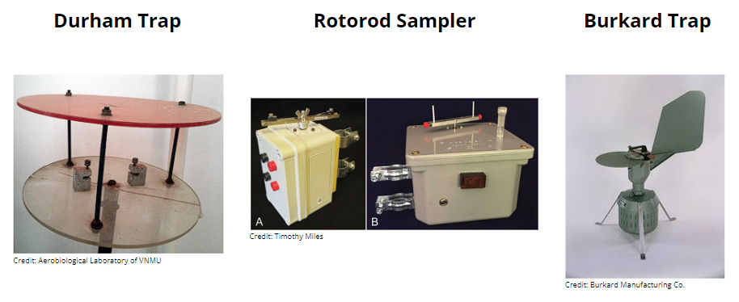

**Competitive Advantage**

The only competitive advantage of the legacy devices is relationships and known service record. Another possible advantage is the repository of stained pollen taxa, however other companies have extensive libraries of images as well.

**Business and Product Shortcomings**

These devices have a very manual collection process, and a very manual counting and identification process, requiring the training of highly skilled technicians to perform the pollen counting process. Peering at the larger corporations' websites who own the manufacturing facilities for these devices, there appears little to no innovation in their business model; most of these companies have been in business for several decades in slow decline.

### 

### Pollen Sense

**Company Overview**

An American-based company in Utah, PollenSense appears to target the Pollen Counting market by selling “low cost” automated detection devices that feed into a cloud-based data repository, serving data through a phone application or through their API for interested researchers and developers. The primary device they sell is the PS-400; a shoe box sized, fixed installation, automatic pollen identification and counting system which uses dark field microscopy with a claimed >90% identification success rate. Data from the device can be viewed directly from the application. Since the device is cloud-based, a wireless connection is required. This device is also low maintenance with a required tape change at least once a month. Users can pay for premium services that permit access to more personalized and localized pollen forecasting.

|  | Website:  <https://www.pollensense.com/>  Phone App:  <https://apps.apple.com/us/app/pollen-wise/id1474856970>. |
| --- | --- |

**Competitive Advantages**

The use of a low cost collection and sensor system, coupled with the automated nature of pollen identification, is the most advanced improvement in the pollen counting industry to replace the legacy devices, signaling a dramatic shift in the Pollen Counting industry. With as many stations as legacy Pollen Counting stations, PollenSense may be poised to replace traditional Pollen Counting methods and agencies. With nearly >20k downloads on the apple and google app stores, users are gaining some sort of intrinsic value from pollen information.

**Business and Product Shortcomings**

With over 60 million seasonal allergy sufferers in the US alone, Pollen Wise only reaches 0.03% of this target audience. Sensor deployment appears to be the weakness. At $3.5k per unit, deployment of their sensors is limited by the number of institutions willing to pay for the equipment and consumables to continue to service the sensors. The average consumer who uses the pollen data premium membership to help make personal decisions is limited to the availability of PollenSense sensors in their area; which may be several hundred miles away. Based on limited research, mold is one of the most difficult to measure; as it requires time for the spores to grow. It is not clear how PollenSense can claim to detect mold with their current sensor technology. No direct method of inserting a prepared sample, measures directly from air.

### Swisens

**Company Overview**

Switzerland based company, offering automated pollen collection and identification system. The company offers its flagship product Poleno Mars at a cost competitive price primarily directed towards the replacement of legacy hirst type collection locations.

|  | Website:  <https://swisens.ch/?lang=en>  Pollen Data:  <https://swisens.ch/ecosystem-pollen-monitoring/?lang=en> |
| --- | --- |

**Competitive Advantage**

Triplicate sensor technology to reduce errors and increase accuracy. Part of the European market where pollen counting is much more prevalent with 400+ counting stations spread across the union. Competitively priced against the manual pollen counting processes, with comparable 10-year price targets while providing significant increase in reporting capabilities. System projected to have a 10 year service life.

Cost: <https://swisens.ch/cost-comparison-automatic-versus-traditional-pollen-monitoring/?lang=en>

**Business and Product Shortcomings**

Unclear if Swisens offers free or paid data management services. Appears that the customer is responsible for handling the data once the system is installed and operated. Taxa identification is via one-time setup service fee; it appears as if this is part of their costing model which would effectively increase the cost of the product for each type of pollen a customer wishes to identify. No direct method of inserting a prepared sample, measures directly from air.

### Hund

**Company Overview**

German based company, offering an automated pollen collection and identification system. The company offers software backend support for implementing the pollen reporting mechanisms of their equipment. The unit uses several types of spectroscopy measurement methods to increase taxa identification success rate >90%.

|  | Website:  <https://www.hund.de/en/pollen-monitor>  Public Pollen Data: <https://www.hund.de/en/service/pollen-monitor> |
| --- | --- |

**Competitive Advantages**

Pollen image repository is the most advanced out of all competitors. Different levels of AI integration allows for self-learning capabilities or comparison against existing repositories of pollen images for identification and classification. The company at large is heavily invested in microscopy and scientific imaging processes; appears to be the most knowledgeable in this field in that regard. The market in Europe is quite advanced regarding pollen counting, with 400+ active collection/counting stations throughout the union. With an active government interest, the research and product availability is far superior than any other region of the world.

**Business and Product Shortcomings**

Initial cost is prohibitive to most; only applicable to large institutions and specific research. The product has no method of directly inserting sample in

Recurring cost is most likely cost prohibitive as well. The Pomo BAA500 uses a turret style cartridge system for depositing pollen on glass slides. This method will require replacement, at an unknown cost; due to the cleanliness requirements and swapping procedure this appears to be very costly.

### 

### Pollen Datasets

A number of pollen data-sets, which include pollen pictures annotated samples, with several standout ones among them, surfaced are:

• POLEN23E is a tiny set of 805 pollen photos from 23 classes.

• POLLEN73S, is a moderate-sized 73 classes and 2523 pictures.

• POLLEN13K, bigger set with more than 13000 photos, but only for 5 classes.

Although each of the above data sets has a lot to offer in terms of creating new, more effective methods for automatically classifying pollen, they are all constrained by the same problem. This is due to the fact that the data sets were not created in a systematic manner but rather by hand and with significant human involvement. All of the aforementioned data sets contain pollen preparation processes that must be performed manually by technicians, such as choosing a pigment to highlight particular pollen particle characteristics and choosing various focus settings for each type of pollen to get the clearest image. This creates significant bias, rendering models developed using such data sets useless when applied to fresh samples obtained from automated pollen collecting devices.

Due to this, its application is constrained when the scale is expanded to include automated systems. The idea of having an automated system to acquire the fresh samples would be defeated if a model trained on such data-sets were to be used, which would need the data pipeline to contain all of the pre-processing procedures carried out by humans. The development of automatic particle analyzers in recent years has led to the creation of some data sets that only use information from fully automated systems. Examples of these data-sets include:

• Data-set-15 has 51,277 total samples over 15 pollen taxonomic groups.

• Data-set-31 is a more comprehensive variant of Data-set15 that includes a few more classes.

The fundamental problem still exists that these classifiers rely on traditional image processing techniques for segmentation, even if the results on these data sets are quite encouraging. Additionally, the intricate patterns created by pollen particles on microscope slides cannot be effectively segmented using these approaches. Despite being excellent resources, Data-set 15 and 31 are not accessible to the general public, which restricts the amount of study that can be done utilizing them. Due to its accessibility and automated source, our data sets alleviate the majority of the problems with earlier released sets.

Other than these datasets, there are other datasets available for certain cost by Geospatial.ai and Ambee. Here is the cost of Ambee dataset for 3 latitude and longitude.

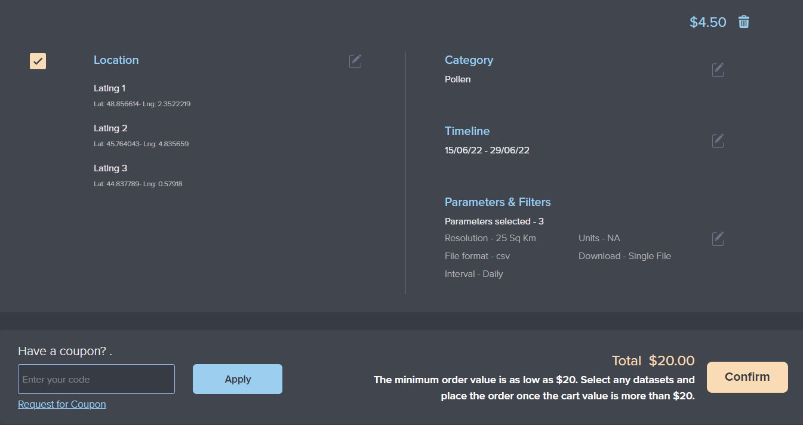

### Competitor Conclusions

For discrete devices, a rudimentary competitor landscape evaluation of cost vs. features is shown in the plot below. One direct observation that can be made is that the market is filled with high cost equipment claiming high pollen identification rates (>90%); based on customer needs the actual number of taxa identification is limited to reporting of three primary groups (grasses, tree, and ragweed). While identification of several thousands of pollen taxa may be necessary for this market, it appears that much simpler options are not being explored.

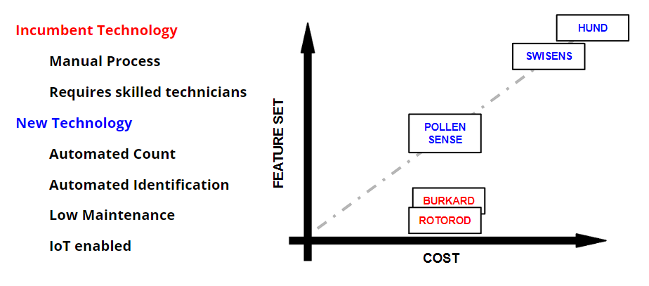

An additional emerging market is the pollen data as a service market. However, through our research, the fundamental pollen data collection process is still handled by the freely available network of stations, supplemented by a few private collection sites. In meetings with several pollen data consumers such as The Weather Channel, WRAL, SERCC, and other outlets; they confirm our suspicions that all services and sources share the same data source and these proposed services do not add fundamental value to pollen information.

## SWOT Analysis

A typical SWOT Analysis is visually tabulated below, highlighting the four areas of strategic business management as compared to the internal and external factors of the business environment.

|  | **Helpful** | **Harmful** |
| --- | --- | --- |
| **Internal Origin** | Strengths | Weaknesses |
| **External Origin** | Opportunities | Threats |

For formatting purposes, the table is broken out into sub-headings below:

* **Strengths**

Internally, our organization has some competencies which the others appear to not have. Our business and engineering prowess will give us an edge in the following ways:

* New look at the problem of pollen counting
* Product concept nests well with the industry need (localized pollen count and classification)
* Product design and price offer low maintenance counting at a much lower price for individual consumers.
* Access to knowledgeable experts in business and technological fields.
* Scope of value proposition ties hardware to software unlike competitors
* Developing more strengths…
* **Weaknesses**

Although we have great talent, a couple of weaknesses have been identified, which may require outsourcing in the interim. These weak points are:

* No experience in the pollen counting and analysis industry
* Minimal experience in product design and development
* Minimal experience in entrepreneurship and business development
* Unknown company with unknown product in market.
* Pollen accuracy education level of consumers is small but critical to our value proposition.
* Tech and AI are still in early phases of development.
* Patents on technology do not exist yet.
* Developing more weaknesses…
* **Opportunities**

In reference to externally observed factors in favor of this business opportunity, a few helpful business propositions have been identified.

* The median product cost in the market has a void. There is no hardware that is priced at the consumer level of less than $300.
* High costs limit the scope of the customer base.
* AI powered forecasting models rely on little to no pollen data and are largely inaccurate.
* Pollen data sets are limited by collection site and therefore are extremely inaccurate for most predicted locations.
* Data competitors rely on existing pollen collection or have costly devices that prohibit true localized pollen counting and classification.
* Climate change combined with healthier living increases consumer awareness of airborne contaminants.
* Healthcare costs continue to rise, prompting consumers to seek preventative medicines when possible.
* Developing more opportunities…
* **Threats**

Threats are factors that can potentially bring harm to a budding organization. Based on the available skill sets, knowledge and experience, or observance of key business operations, the following threats have been identified:

* Legacy processes are hard to replace due to status quo established procedures and equipment. (“don’t change it if isn’t broken”)
* AI forecasting models have a significant time in the market and increased consumer awareness
* Large weather forecasting companies have an advantage in data mining and greater information access.
* Large companies have resources to copy the Pollen ID system at a lower cost with greater access to distribution channels.
* Loss of IP to potential competitors before final product design or full release.
* Government regulations that govern classification and reporting of airborne contaminants that may impact pollen counting and classification product design.
* Developing more threats…

## Business Risk Assessment

A typical risk assessment consists of the identification of risks, evaluation of its likelihood and severity, and identifying an action necessary to be taken in order to mitigate that risk. An example of a simplified risk matrix and the risk score is found in the chart below.

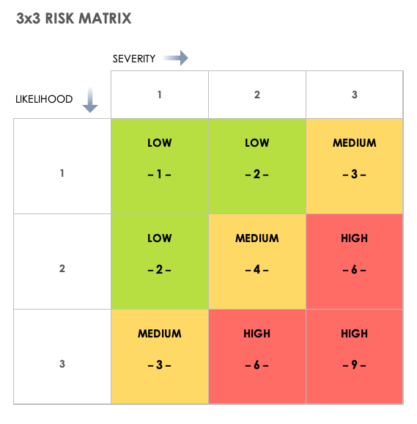

Through the business evaluation process using the 3x3 Risk Matrix, Pollen ID has identified a few key business risks using the table above and their potential impact to our business model along with potential mitigation strategies. Our two most significant risks are assessed to be the accuracy of our pollen counting system and the threat from competitors to mimic our process. We expect to mitigate the risk to our accuracy by comprehensive developmental testing and model training before our initial launch period. Additionally, we have designed our model to continuously retrain based on collected data, thereby increasing our accuracy over time. Pollen ID will also begin the patenting process to protect our intellectual property from mimicking by competitors. We feel the crowd sourced pollen collection schema is a critical component of our system and must be protected. Finally, we intent to continue researching our next iteration of our sensor technology, such as PM2.5, to introduce with follow on devices.

| **ID** | **Risk Statement** | **Like** | **Sev.** | **Risk**  **Score** | **Solution / Mitigation Plan** |
| --- | --- | --- | --- | --- | --- |
| 1 | Pollen counting accuracy does not meet the industry standards | 2 | 3 | HIGH | Adequate field testing with Pollen Base to ensure classification models have high accuracy. Ensure AI model upgrade on Pollen Scout routinely |
| 2 | High technological advancements serve as a barrier to entry into the market | 1 | 2 | LOW | Technology in this field is rather low and accessible. Pollen ID will need to continue to be proactive in sensing and AI technologies to ensure they are ahead of the technology curve. |
| 3 | Large companies with significant resources mimic the collection model at lower costs. | 3 | 3 | HIGH | Pollen ID will need to be the first to market with consumer focused data, software & hardware to gain a foothold before other companies move to market and create barriers for entry. Pollen ID will need to patent the process that allows cheaper collection with  Pollen Scout along with hardware and AI. |
| 4 | Sale of collected pollen data to forecast service providers possible cannibalization of pollen device sales with customers wondering what they get for their purchase that cannot already be found via forecast apps. | 2 | 2 | MED | Pollen ID will need to focus on device purchase and placement as the first phase of business to ensure enough devices are in operation to crowdsource pollen data. PollenID must offer other services at a price to consumers that will reinforce pollen scout device requirements and foster a sense of exclusivity and desirability. PollenID will also need to build a sense of social responsibility within customers to help offset any buyer’s remorse. |
| 5 | Consumer base does not find localized pollen counting a critical need | 1 | 3 | MED | PollenID will conduct detailed customer surveys and analysis to determine purchase reservation prices and willingness to buy before launch of products in a region. Initial results show an average of 5% of the total population would be interested in purchasing a device that counts pollen. |
| 6 | Government regulatory requirements implemented for air quality analysis that impacts pollen collection technology. | 1 | 1 | LOW | It is unlikely that government agencies will increase pollen identification regulations in the near term. PollenID will continue to watch developments while providing the most accurate pollen classification as possible. |

# PRODUCT DEVELOPMENT

## Technology Analysis

A network of 400+ manually controlled pollen traps is used to monitor pollen across the world. The volumetric Hirst-type pollen trap is the most popular in the world. It is available in a variety of variants, including VPPS1000, VPPS2000, and VPPS2010. Other common pollen traps used for short-term exposure assessments are Durham, Cour, and Rotorod samplers, which are non-volumetric air sampling devices. Electrostatics are used in ionic spore traps to draw in the particles. The effectiveness of the system as a whole is impacted by the airflow created by a trap since pollen is seldom present in the surrounding air. A Hirst-type trap has a relatively moderate airflow rate of 10 to 20 l/min, but an Ionic spore trap may attain airflow rates of up to 660 l/min. Aerobiologists with the necessary training procedure collected samples in the lab every 1 to 7 days. The number of covered areas, intrinsic precision, and responsiveness of pollen exposure models and predictions are all constrained by manual sample inspection.

The 1990s saw the beginning of automated methods for processing pollen samples. While some of the suggested methods rely on picture recognition, others involve biomolecular analysis, such as DNA, or chemical identification. All of these procedures have excellent performance, but they all call for manual handling and meticulous sample preparation. Because of the large processing delays caused by these semi-automatic systems, some of the work must be done by people.

Recent years have seen advancements in the testing, evaluating, and creation of tools and techniques for complete automation of pollen sensing. Among the proposed systems, one can distinguish between holographic detectors, such as the Swisens Poleno Basic (2018) and optical detectors that take advantage of bioparticle fluorescence, like the Plair PA-300 (2016) and Swisens Poleno Standard, and devices that use microscopy and automatic image recognition, like the Hund BAA500 (2015) and Yamatronics KH-3000 (2007) systems (2018). The solutions based on top-notch microscopes and fluorescence are pricey and haven't gained much traction yet. Holography is heavily used by promising new automated pollen detecting systems.

There is a long history of automatically identifying pollen in microscopic photographs. The kind and caliber of technology utilized to record microscopic pictures, as well as the sample preprocessing which may be manual have a significant impact on the quality of the identification. Early techniques classified texture attributes statistically on pictures captured by pricey scanning electron microscopes with an accuracy of 94.3% across six classes. Later studies used neural networks with rigorous human feature selection to identify pollen in light microscope pictures, and the results demonstrated 87%-97% accuracy on three to five classes. With well produced photos focused at a pollen grain, all of these techniques are effective. A study on pollen identification in images revealed a 90% detection rate across three classes. Up to 98% detection precision on five classes and 87% classification accuracy on 15 classes are reported in the most recent detection findings employing holographic pictures. Deep neural network-based object and pattern identification has recently advanced to the state-of-the-art.

## Concept Idea Generation

The process of pollen identification can be broken down into two sub-processes:

**Pollen Collection:**

* The two commonly used collection methods are:
  + Rotorod (Patented Product :- costs between USD 5K and 10K)
  + Burkard spore trap (7 day volumetric sampling).

Both the methods rely on the pollen in the air impacting against a sticky surface (greased rod for the rotorod and Melinex tape for the Burkard spore trap). Both the methods, in the current state, are labor-intensive (replacing rods/tapes) for an average consumer. There is room to improve these methods by means of automation (automate rod changing and greasing in case of rotorod). This could be of use for the pollen counting step.

* To confine pollen grains to a very thin space by using charged plates. The pollen can then be imaged by a camera and analyzed.
* Pollen could be collected by air suction and passing it through a venturimeter like structure.

**Pollen Counting and Classification:**

* Pollen counting can be done via image analysis. Images can be acquired using a low cost camera and microscope (foldscopes cost < 1 USD, some high magnification scopes cost <20 USD). Based on our interaction with the employees at the NCDEQ, the minimum microscope magnification needed would be around 100X.
  + The acquired images can then be identified by using a classifier. Potential training sets can be obtained from the NCDEQ (They have thousands of images of all types of pollen).
* The other option is to identify pollen by chemical analysis. The pollen collected can be incinerated and the volatile chemicals released from it can then be analyzed using chromatographic techniques.

## Concept Development

### Customer Derived Requirements

Through various interviews, surveys, and observations we have identified several attributes and criteria of the needs expressed by multiple customers regarding pollen counting and pollen analysis. These results are summarized in the table below.

Table: Itemized Customer Needs

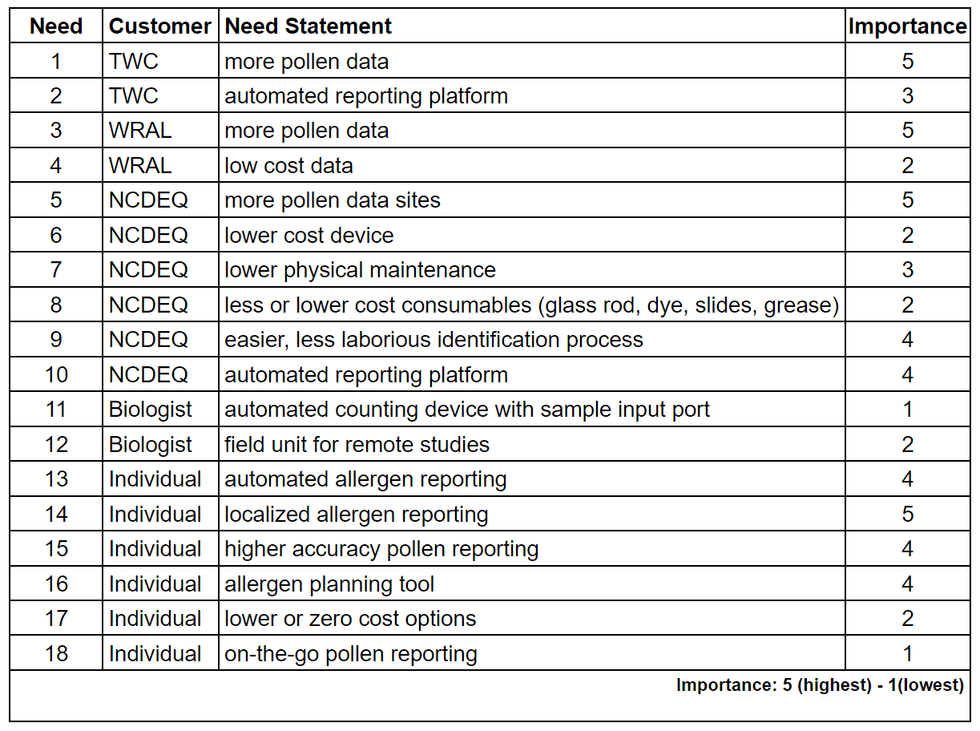

Multiple customers, even those in different consumer segments, had common needs and desires. For clarity of this assessment, the table below was derived to reduce the needs list to a more concise format. For comparison purposes, the leading competitors in the field of pollen counting (as previously described in the Competitor Analysis section) are qualitatively assessed with regard to these customer needs. This will be used as a template for designing technical requirements for our products and services.

Table: Customer Needs Summary

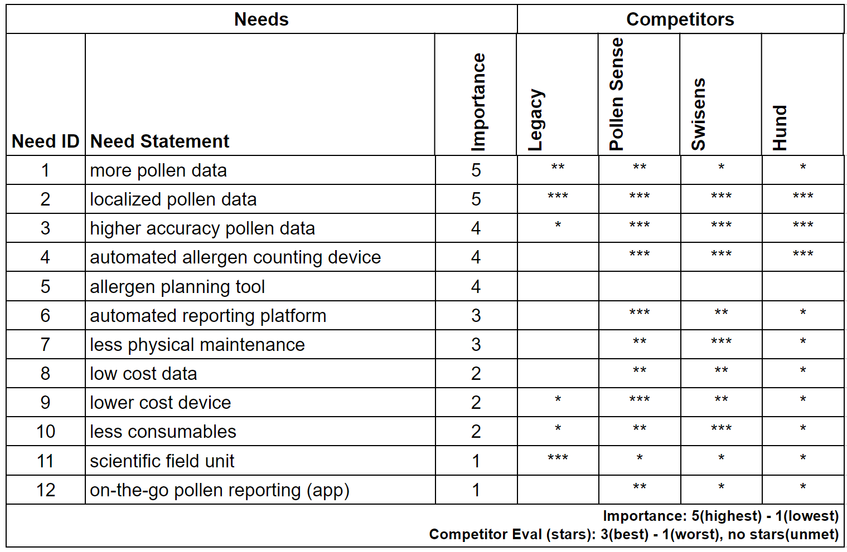

From the above table, the competitors on the market have already established themselves as competent leaders in the field of automation through the use of various sensor technologies blended with artificial intelligence capabilities for automatic labeling for detection and classification.

Noticeably, no candidate provides an interface for allergen planning, rather providing pollen data forecasting; a probable distinguishing feature in our proposed solution could be providing additional feedback features to potential users.

Another headlining attribute, while not surprising, is the absence of a low-cost option as the market has been dominated by high cost manual processes with inflated cost tools due to the relatively small size of the market. Through our analysis of the consumer market, there is an untapped potential in individualized pollen reporting.

### 

### Technical Requirements Definition

From the analysis performed previously in the customer needs assessment, the various needs were tied to a hard quantifiable metric as outlined in the table below. This table will be utilized in comparing incumbent technology with the proposed devices and services as offered by Pollen ID.

Table: Technical Design Metrics

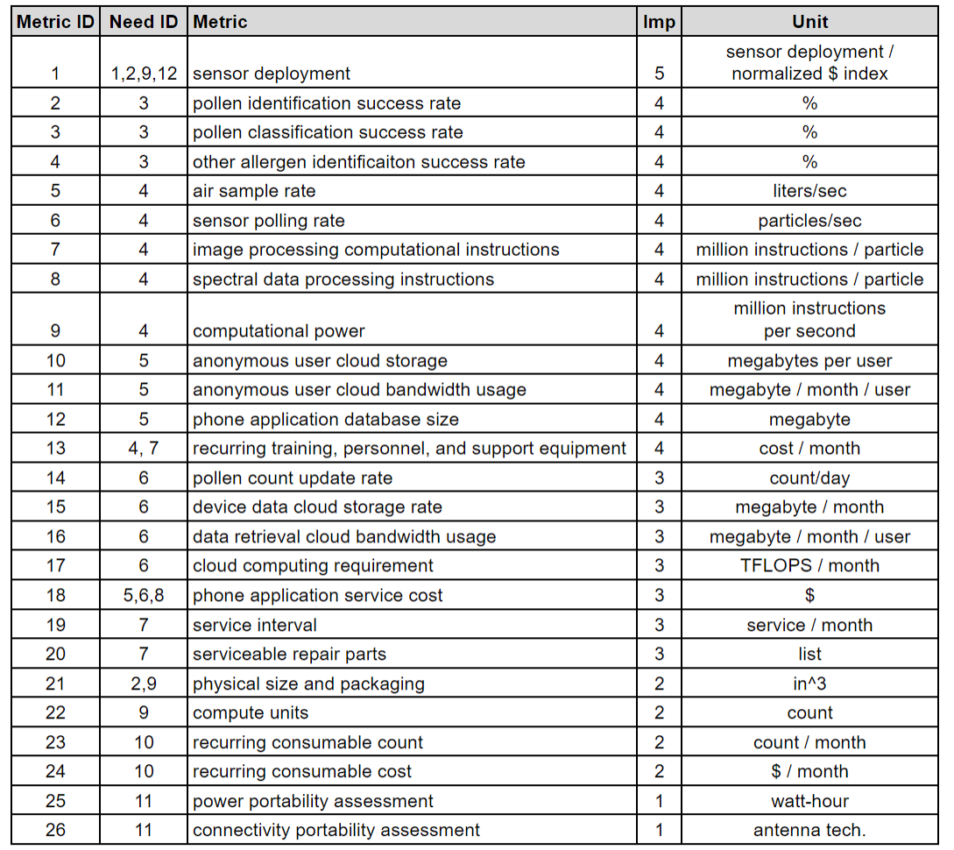

Generally speaking, the metrics above are concerned with cost, computational requirements, and storage requirements for the proposed customer needs. Each of these requirements will be assessed against the relevant holistic solution subcategory or sub-system. A brief description is provided below for each metric.

* **Sensor deployment** - in order to compare the service reach and data density of current devices, the number of sensors to be deployed over a region compare to relative cost will provide a useful comparison of the possible pollen data map density per unit cost.
* **Pollen and Other identification and classification success rates** - the percentage of success of discerning allergens from non-allergens, and of those pollen from all detected allergens, further still the ability to discern different pollen taxa.
* **Air sample rate -** the air ingestion rate of the device.
* **Sensor polling rate** - the rate at which pollen particles are detected.
* **Pollen Count update rate**  - the number of pollen samples taken per day.
* **Image processing instructions** - define the computational workload of AI pollen detection by image processing.
* **Spectra data processing instructions** - define the computational workload of AI pollen detection by other sensors.
* **Computational power** - aggregate value of polling rate and processing instructions to give a definition as to how fast a proposed processing unit must operate in order to provide useful pollen counting data.
* **User and Device Cloud Storage** - anticipated data storage of subscription users and data coming from pollen sensors.
* **User and Device Cloud Bandwidth** - anticipated data bandwidth utilization of subscription users and from pollen sensors.
* **Cloud Computing** - anticipated pollen allergen forecast and other AI computational tasks, normalized to nodal count.
* **Phone App Database Storage** - the amount of data anticipated to be stored locally on a user's device, instead of the cloud.
* **Phone Application Service Cost** - cost of phone application to a user.
* **Recurring personnel and material cost** - the personnel cost and materials other than that directly related to the operation of the pollen capture and counting device such as microscopes and cleaning products.
* **Service Interval** - anticipated human planned maintenance interval.
* **Serviceable Parts** - anticipated end-user serviceable list of parts.
* Physical size and Packaging - physical dimensions of the product.
* **Compute Units** - number of individual compute units required to perform pollen counting task.
* **Recurring consumable count** - number of sku’s necessary to stock in order to service a device.
* **Recurring consumable cost** - the cost of the consumables at the prescribed interval.
* **Power Portability Assessment** - how much power and energy is required to operate the device.
* **Connectivity Portability Assessment** - what antenna and data communication channel is available by the device to transmit/receive data.

### 

### Product Concepts

A common thread between any potential solution is that the lack of pollen data is the root of the primary issue in our primary and secondary markets. There are examples of several pollen data services which utilize recycled data that is already available from several sources and platforms. Crucially, the shared information is coming from ~60 publicly funded pollen counting sites across the US. To put that into context; if these counting sites were evenly spaced around the US, each collection site would survey an area of ~70k mi2 (approximately the size of Washington State). With that in mind, our concept ideation is centered around the primary differentiating factor, the development of a widespread network of pollen counting nodes that will rival current competitors in the market; it is assumed that other components of the system mimic current business practices; such as deployment of an app and cloud services, as is explained below.

* **Common Design Elements**

The total business and engineering concept of a pollen counting service entails: 1) development of low cost sensors, in order to deploy 2) a widespread nodal network of devices that 3) enabled by artificial intelligence and cloud computing resources can provide individualized pollen information. With the primary goal of sensor deployment and collection of data to a common cloud computing platform, the deployment of any additional services is only limited by development time and formulation of software which is infinitely scalable with no need for additional hardware. Some key services have been ideated, but not limited to those below:

1. Development of a Pollen Data Repository and API
   1. General Pollen and weather forecasting.
   2. Agricultural Yield modeling.
   3. Agricultural health monitoring.
2. Individualized Allergen Services via Phone Application
   1. Localized Pollen Forecasting.
   2. Travel pollen alerts.
   3. Individualized pollen sensitivity assessments.
   4. Individualized allergen planning and alerts.

With the above proposed software service in mind, and the knowledge that a proposed device solution will incorporate the necessary sensors to detect pollen and weather metrics, backed by a capable cloud computing platform, the focus of ideation will be centered around the deployment aspect of Pollen ID’s design solution.

* **Fixed Nodal Network (Competitor Baseline)**

Similar to the PollenSense and Swisens networks, with medium to low cost devices which can perform taxa analysis at a fixed location. The device is meant to be retailed to regional collection sites and cities to perform pollen counting analysis. Data reported by these devices are automatically uploaded to a cloud service, where the resulting analysis reports are disseminated to the customers via a phone application or data API.

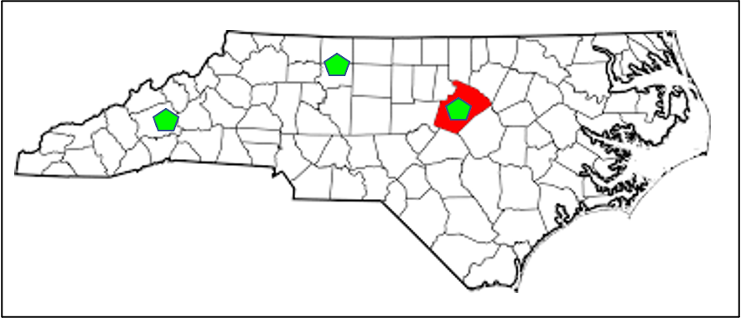

(not to scale, relative density illustration)

* **Fixed Mixed Nodal Network (Concept 1)**

A mixed network of pollen counters comprises numerous low cost nodes that can accurately determine count but have limited ability to differentiate taxa, supplemented by a regional higher-cost node which can identify taxa more accurately and help train the low cost nodes through artificial intelligence. This mixed network would help solve the localized accuracy pollen count issue while still providing moderate taxa analysis by reporting gradients of specific taxa between the more powerful nodes. Of key importance is that the potential low cost device is marketed directly to consumers so that the required connectivity will be supplied by the customers home internet connection. The higher performant nodes can be installed at parks and locations of business.

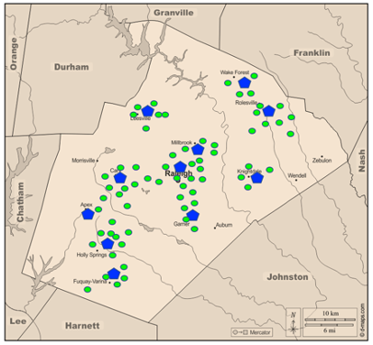

(not to scale, relative density illustration)

* **Roving Carrier Network (Concept 2)**

Similar to fixed nodal network devices, however, to get a higher number of samples and locations, the device will be attached to partnership carriers such as Fedex, USPS, and UPS who have long carrier routes across the country. The device will sample the air when stopped along the vehicle route and report pollen count, weather data, and location and transmit to the database via LTE.

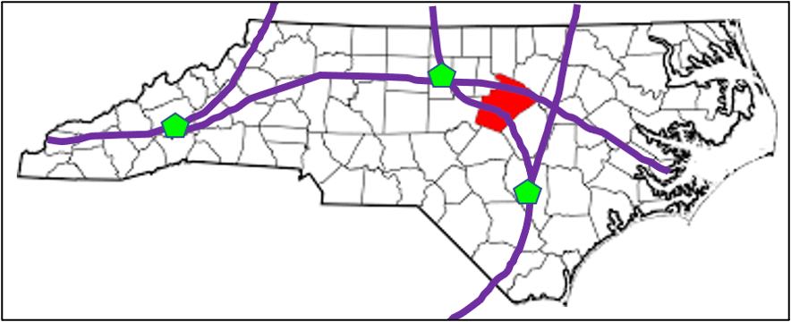

(not to scale, relative density illustration)

* **Roving Service Network (Concept 3)**

Similar to roving carrier networks, however, to get a higher number of localized regular samples, the device will be attached to a company service vehicle, or even local municipality vehicles such as public school buses, garbage trucks, and local taxis.

## 

(not to scale, relative density illustration)

## Study Models

Pollen collection, identification and identification from air is an extremely complex process mainly due to similar sizes of pollen grains and other particulate matter in the atmosphere. Our device claims to provide accurate pollen data to our consumers from the atmosphere in their vicinity. In order to meet the requirements of our consumers and for our claims to hold water, we have divided this mammoth task of providing accurate pollen data into smaller subtasks which will help us develop and assess the technical feasibility of our prototype, thereby helping us develop a good, final product. The smaller sub-tasks are as follows:

### Pollen Collection

This is the first task that will be performed by our proposed device. The device will collect pollen from its surrounding air. Collecting the pollen on a surface would mean the use of a physical filter. This filter will need to be replaced from time to time and will therefore add a maintenance cost for the user. Our aim is to accurately collect pollen and minimize the maintenance cost. This can be achieved by assessing all the available technologies and selecting the best features amongst them while making it affordable for the end user. Conventionally, pollen collection has been done using the following methods:

* Rotorod:
  + It is a small plastic rod which is coated with grease and rotated at high angular velocities so that air-borne pollen sticks onto the grease. This technology has been in use for more than two decades and the application of grease/ petroleum jelly for every collection instance is labor intensive and would incur high maintenance costs.
* Tape and Reel (Burkard Spore Trap):
  + In this type of a collection system, air impinges onto a sticky tape which is wound on a reel. The pollen in the air sticks to the tape whilst unwinding from the reel. Once pollen is collected, the part of the tape that was exposed to air is cut and further manually analyzed.
* Filters:
  + A suction fan is used to suck air which would deposit pollen grains and other debris from the atmosphere onto a filter. The porosity of the filter is such that it will allow everything but pollen (and similar sized particles) to pass through it. Thus, the filter will have collected pollen (as seen by the darkening of the filter) and the concentration of the pollen in the air can then be calculated from the area that is darkened. This method is extremely cost efficient to implement, but can be highly inaccurate and high-maintenance in the long run.
* Air flow:
  + Competitors like SwisensPoleno have used a sheath of clean air to direct air from the atmosphere through a long tube at a very specific flow rate. Pollen in the air is then analyzed using a bunch of highly sophisticated sensors and the air is then expelled from the system. Therefore, the device does not collect any pollen thereby eliminating any maintenance cost. However, the usage of sophisticated sensors makes this device unaffordable for the everyday user.
* Particulate Matter (PM) Counters/ Sensors:
  + These are small sensors integrated with simple electronic components to suck in air from the atmosphere, count the particles that qualify a certain size threshold (e.g. PM2.5 sensors are used to count particulates of the order of magnitude of 2.5μm) and then expel the air through an outlet. These sensors are inexpensive, low maintenance and work as reasonably accurate and reliable counters, something that can be used in our proposed device.

These are some of the engineering solutions that were researched. The best features amongst these technologies will be critically assessed and used in our physical prototype.

### Pollen Detection

When the device collects air, it is inevitably going to collect dust particles or dead insects along with pollen. The first step towards accurate pollen data reporting would be to detect whether the collected matter is actually pollen or not. The detection of pollen from non-pollen particles can be slightly easier than imagined, mainly due to the high sphericity of most pollen grains. Most pollen counting facilities use the rotorod to collect pollen and then stain the rod using a dye. The pollen collected is selectively stained while the dust particles and other debris remain unstained. Pollen counters at the various pollen counting facilities in the country refer to a handbook containing images of all types of pollen grains. They then manually compare the image in the handbook to the particle on the rod and thus identify the particle as pollen. With the availability of inexpensive computing power and image processing capabilities, we can now image the collected particles and classify them as ‘pollen’ or ‘non-pollen’. A very crude implementation of this would be something as simple as counting the number of circles in an image and labeling them as pollen. This classification technique can then be improvised upon, by using more sophisticated image processing algorithms and AI models to analyze the contour, sphericity, size and texture of the particle before classifying it as pollen.

### Pollen Identification and Classification

Pollen of different taxa affects human health differently. For instance, a concentration of 60 grains of tree pollen per cubic meter of air is considered to be ‘low’, while 60 grains of ragweed pollen per cubic meter of air is considered to be ‘high’. Thus, only counting the total number of pollen grains collected per unit volume of air is not sufficient for an allergy patient. Sometimes, a person may be allergic to only a certain taxa of pollen in his/her surroundings. Therefore, it becomes imperative to classify the collected pollen into the correct taxa in order to provide accurate pollen data.

Today, the pollen counting individuals at the various pollen counting facilities in the country manually count, identify and classify the collected pollen into their respective taxa. The aforementioned handbook of images of various types of pollen proves to be of great help here. However, the handbook is not updated and the classification is solely dependent on the expertise of the operator. This can easily result in biased classification.

The task of automating the classification is extremely difficult, but can be performed in a few ways:

* Chemical analysis of pollen:
  + The collected pollen can be burned and the volatile organic chemicals (VOCs) released by it can be analyzed using chromatography techniques (gas chromatography in particular). The concentration of the analyzed chemicals will correlate with the concentration of the collected pollen. Based on the quality of chromatographs available, this method can be extremely robust, precise and ultimately, unaffordable for the everyday user. Knowing this drawback, such sophisticated instruments will only be used by government institutions, research labs etc.
* Spectral analysis of pollen:
  + When subjected to UV light, the different taxa of pollen give rise to a unique spectral pattern. The spectral pattern and its intensity can then be analyzed to classify pollen into different taxa. This technique is quite promising as prototype building will be more affordable and so will be the final product.
* Inculcation of factors affecting the pollen in a region:
  + Our device aims to provide localized pollen data to the end user. Therefore, by knowing the characteristic spectra of the collected pollen, and other attributes such as the texture, size, contour etc. along with knowledge of the local weather conditions, the vegetation grown, and the topology of the land near the device will greatly help shortlisting the taxa of the collected pollen.

### Pollen Sensitivity

Several research papers indicate that the primary mode of allergy symptom aggravation is a function of pollen granule condition. Pollen grains that burst and break into multiple fragments cause more allergies than whole pollen. Thus, along with identifying whole pollen grains, it is necessary to identify pollen grain fragments. The key engineering factors that need to be assessed are yet to be determined.

## Concept Selection

### Selection Summary

A quantitative assessment of the various product concepts is outlined in the table below. Note that “Fixed Nodal Network” is closely aligned with current competitors for comparison, and the three remaining concepts are derived from product innovation design sessions.

Quantitatively, the fixed mixed nodal network wins the concept analysis using Pugh analysis, with marginal gain to the competitor but surprisingly wide evaluation from the other two design alternatives. Notably, the roving network designs lost considerable points on deployment characteristics due to robustness requirements of the physical design; as these devices would need to withstand significant wind, rain, and vibration while in service.

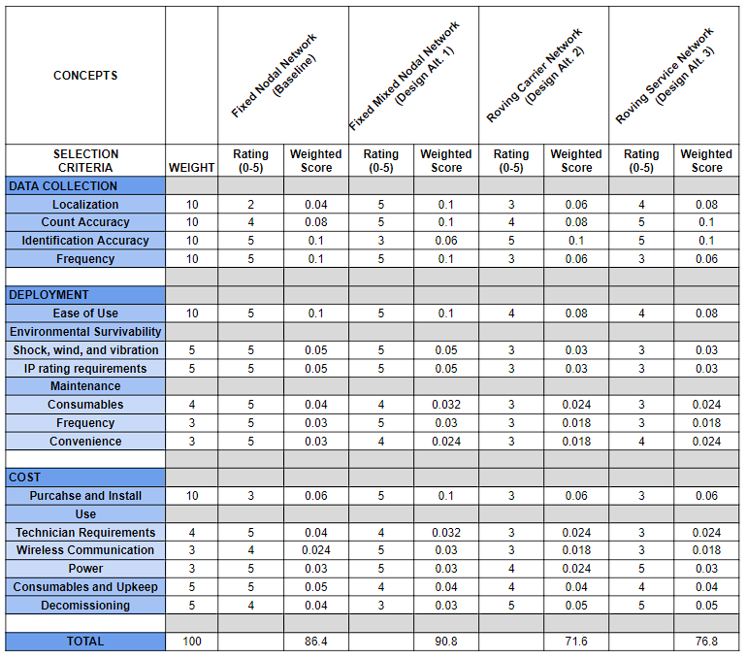

### Selection Criteria Description

A refined description of the selection criteria is provided for completeness.

* **Localization** - the ability to provide regional accuracy to a specific customer, inferring that a pollen sample can be taken within a “reasonable” distance within a reasonable window of time.
* **Count Accuracy** - ability to count pollen and provide accuracy of the count over a specified area.
* **Identification Accuracy** - ability to identify a pollen particle and reject other particles.
* **Data Collection Frequency** - relative rate of sampling at a location, real-time having highest score. High frequency of sampling in a specific location, higher score.
* **Ease of Use** - the relative ease of use of the device covering install, operating, removal, repair, and storage. Less steps to use, higher score.
* **Shock, Wind, Vibration** - relative cost of a design with respect to survivability in an operating environment, cheaper is higher score.
* **IP Rating** - relative cost to sealing a unit against water ingress; cheaper is higher score.
* **Consumables** - relative cost of required materials or services to keep the device operating; cheaper is higher score.
* **Maintenance Frequency** - relative frequency of maintenance, such as cleaning or storing away when not in use. Less maintenance, higher score.
* **Convenience** - ease of performing maintenance on equipment, which may also encompass ability to get to device when a problem is reported. More convenient, higher score.
* **Purchase and Install** - sum of costs to put in place; lower cost is higher score.
* Technician Requirements - sum of possible costs including travel to unit, shipping of troubled units, performance of RMA process. Fewer anticipated technician trips, higher score.
* **Wireless Communication** - cost of consumer or PollenID to operate wireless channels to be able to communicate with devices. Lower cost, higher score.
* Power - cost of consumer or PollenID to supply power to device. Lower cost, higher score.
* **Decommissioning** - amount of waste to deal with when a system or device needs to be taken offline. Less waste, higher score.

### Relevant Competitor

Of the competitors in our research, Pollen Sense is more closely aligned with our target market and proposed solution. Critical criteria for comparison between our products rely on a few key factors:

* **Higher Resolution Pollen Count (Localization)** - by deploying lower cost devices, PollenID can obtain up to 10x the pollen map resolution as compared to one PollenSense device.
* **Less Maintenance** - Whereas the competitor device requires a monthly tape reel change, a consumable which must be ordered directly from PollenSense, our product will require less maintenance and no costly consumables.
* **Different Market** - cost competitiveness of PollenID means that we can enter the consumer market, whereas the PollenSense device at nearly $4k per unit is still a commercial device to be sold to large institutions at low volume.

## 

## 

## Detailed Design

### Product and Service Model

Pollen ID’s product and service solution to the pollen counting problem is through the mixture of high and low cost devices connected to an AI-enabled cloud-sourced data repository. Current pollen taxa identification and counting systems utilize expensive detection techniques to achieve reliable and repeatable results with accuracies >90%, which are intended to service several hundred square miles. While our Pollen Base device is intended to mimic current offerings on the market, our network solution will be supplemented with the deployment of simpler nodes that will resolve the pollen counting resolution problem, providing aggregate pollen conditions in more locations with more representative pollen reports in users’ backyards. In addition, data harvesting of a larger dataset will allow penetration into secondary markets which will expand PollenID’s customer base.

A holistic solution diagram is shown in the diagram below.

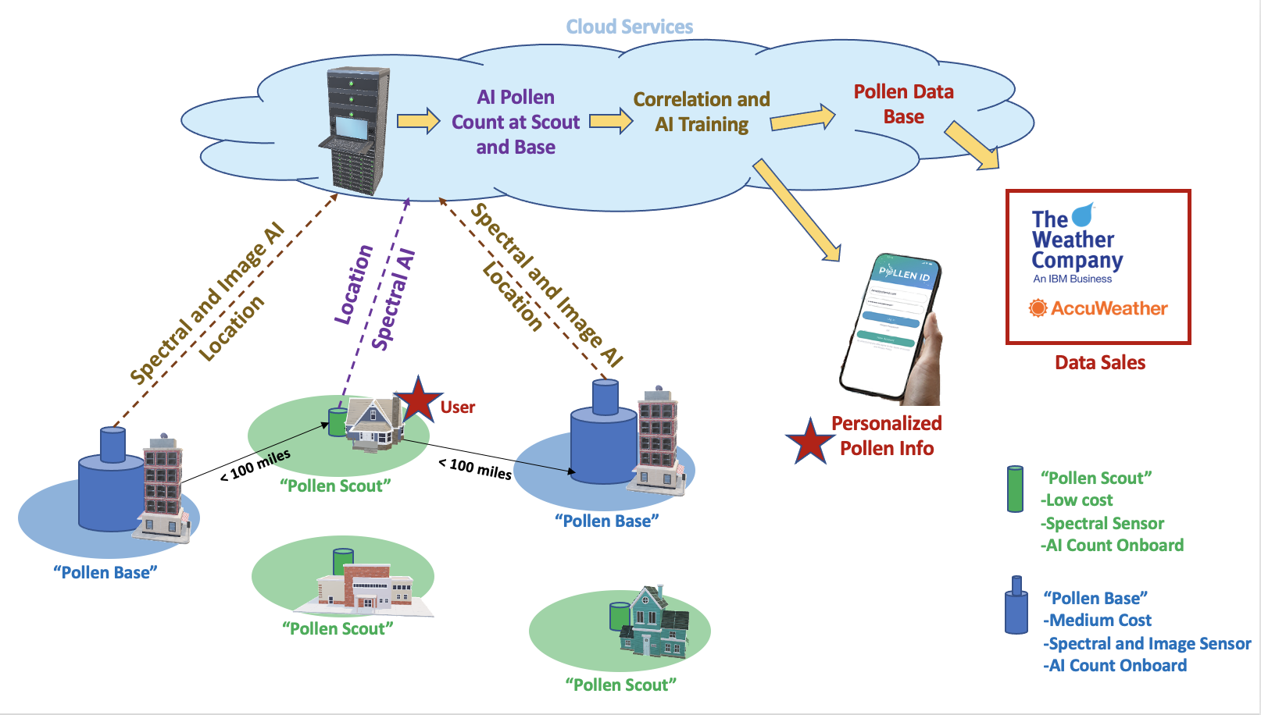

This system, coupled with numerous users will constantly feedback and train the network and AI algorithms to increase the predictive accuracy of future pollen forecasts, pollen identification accuracy; as well as other criteria personalized to the user such as allergy medication timing, and sensitivity awareness to specific pollen types.

### 

### AI Pollen Counting Model

We use object detector YOLOv3 to further enhance our pollen counting model. Given an image of a single depth layer, our pollen detection model calculates the bounding box around each pollen grain. We use a manually annotated portion of the pollen data[17] in order to train a pollen identification model. The depth layers from just two days are tagged due to the high time and labor overhead and the expert knowledge required for human image annotation.

The dataset contains days picked from the second part of May, which is when the tree pollen season ends and the grass pollen season begins. As a result, the collected samples can contain both types of pollen. To reduce the effects of seasonal fluctuations, ensuring identical pollen kinds and similar weather conditions for training and testing, two sunny days are chosen that are immediately following one another. On a rainy day, there is significantly less pollen in the ambient air. The 9,170 depth layers and 9,059 pictures of pollen grains to be discovered are spread throughout 1,077 processed samples in the labeled data set.(46% of the data are pollen-free).

Over 15 different varieties of pollen are included in the data collection. One day is divided into training and choosing the top-performing model for training, with training taking up 80% of the time.It is decided that allocating training and testing sets on two different days will allow for the capturing of the daytime-dependent pollen distribution, which will result in a meaningful measure of detection accuracy. The bounding boxes should be regarded as approximate because not all photos will have a ground truth bounding box and pollen that are perfectly aligned.

We leverage an existing PyTorch YOLOv3 implementation for the detection system that has been customized to operate with our data set and pre-trained on the ImageNet. Resampling the image to a squared form and randomly flipping it horizontally are both included in image pre-processing. Multi-scale training is utilized, and the image size is arbitrarily changed within the range [320, 512] with a step size of 32, just as the original YOLOv3 implementation.

Data post-processing: We perform a series of post-processing operations on the predicted bounding boxes and the manually labeled data, which we take as the ground truth, in order to assess the efficacy of our pollen detection model:

(1) merging bounding boxes, and (2) removing bounding boxes whose area is below a threshold. Since the detection model may predict many bounding boxes for each pollen, the first post processing step is essential. To combine several (potentially inaccurate) prediction bounding boxes into a single bounding box, for which non-maximum suppression is used.

If two bounding boxes must be merged, a threshold intersection over union (IoU) factor of 0.5 is employed as the criterion. We exclude any putative pollen grains that are too small (less than 0.5% of the image area) in the second post-processing stage. This filtering phase is important since it has been found that small, broken, or only partially visible objects make it difficult to detect pollen with the appropriate accuracy. Based on our training and validation data sets, the thresholds were determined empirically.

YoloV3 architecture

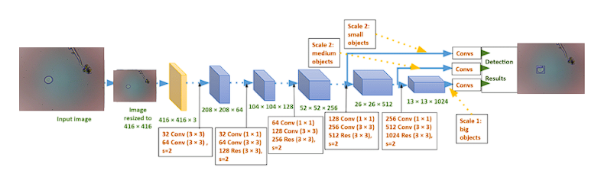

**Results of the detection performance:** The remaining predicted bounding boxes are utilized to validate and test the performance of the pollen identification model after the preprocessing stage. On the test data set, our model produces an F1-score of 0.88 and an average precision of 0.9. We consider a detection to be accurate if the IoU between a predicted bounding box and the ground truth bounding box is more than 0.5. Based on the results, we determine that the test data set's average precision is 90%.

Here is the output of pollen detection where it shows multiple pollen detected:

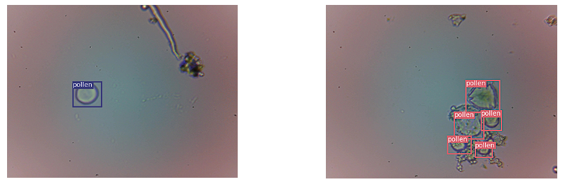

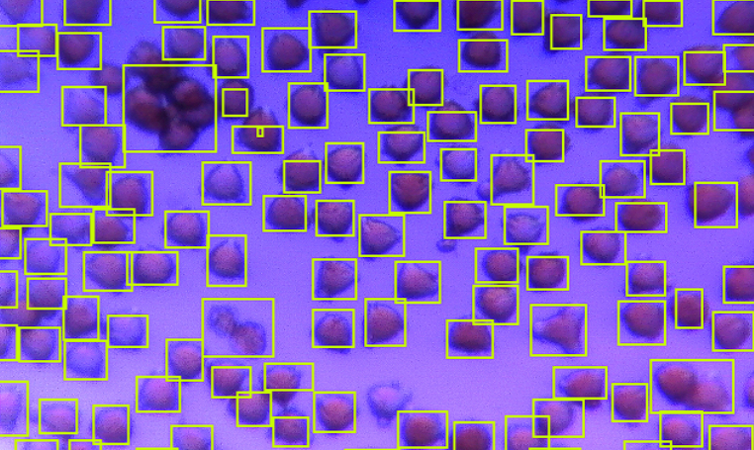

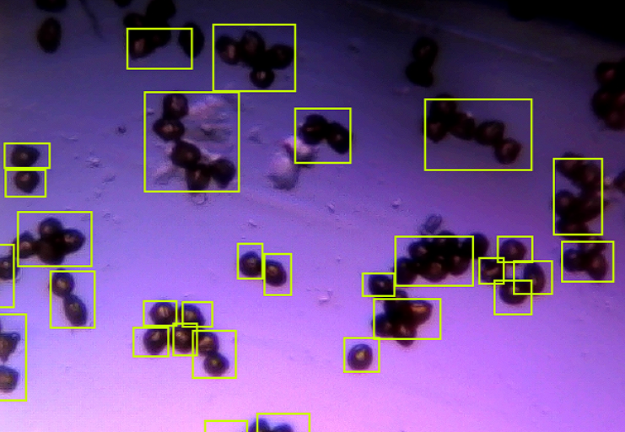

### AI Pollen Classification Model

As mentioned previously the dataset contains various types of pollen. To classify different types of pollen we need to label the dataset with their individual pollen taxa and using the same YOLOv3 model we can classify different types of pollen. The image below is just a sampling of the pollen grain diversity which the proposed system will need to separate into. One important feature of pollen however, is that all of these pollen grains can be segregated into regions. While the keen eyed may recognize the drastic computational requirements in order to identify hundreds of thousands of different pollen, each region would instead focus on <50 individual pollen taxa of interest.

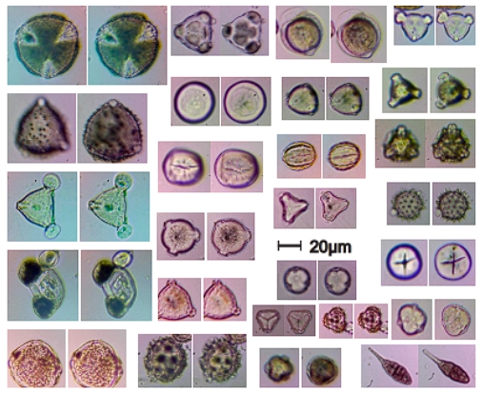

In addition to the individual pollen tax identification, the proposed AI system will also contain a training algorithm that will have to correlate sensor data from a pollen scout with verified image based data. As can be shown in the software training model architecture below, the correlation of the inexpensive sensor data from a Pollen Scout with the positive verifications of the Pollen base is a major technical solution that needs to be in place in order for PollenID to fully realize the proposed business plan.

The diagram below highlights the programmatic process of how it is intended for the Pollen Base to build a usable neural network for the Pollen Scout; for without it the Pollen Scout customer facing product would be severely limited in its ability to deliver on its promised features.

At a minimum the Pollen Scout must differentiate between pollen and non-pollen, which through white paper analysis is relatively straightforward exercise. Given this initial goal in proving a neural network could achieve this, the system would then need to be trained on spectral data from discrete pollen taxa groups, as well as other sensor data with the intended goal of separating pollen particle detection into four separate groups: grass, ragweed, and tree.

The diagram below shows how the pollen id system (from data extracted by the Pollen Base) is intended to collect and train the lower cost Pollen Scout device. Taking spectral data and the image classification prediction, along with other weather sensor information, the model can iterate and self validate or retrain as necessary. With a large database of images and corresponding spectral data, the Pollen Scout will provide better predictions over time.

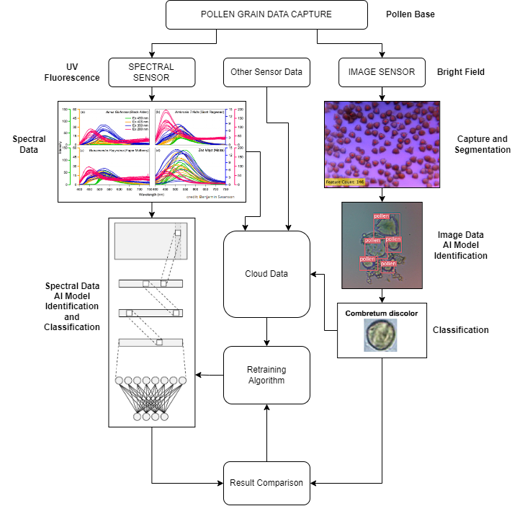

### AI Pollen Forecast Model

The forecasting model must be trained on data that will be accessible when we need to make a prediction. It will suffice to train the model on pollen counts using weather data from the previous day if we want to know tomorrow's pollen levels and we have a summary of today's weather available. If we just need a rough estimate of today's count based on the weather, the issue is easier to solve because the input and output of the training data are both aligned to the same day. Another approach would be to train using past data projections, which would produce estimates with a wider range and offer greater application-specific flexibility.

Due to the simplicity of acquiring the data, we chose to train the model using daily weather summaries from Dark Sky (https://api.darksky.net/forecast/) as the inputs and same-day pollen counts as the output. For many use scenarios, this is not ideal, but it can serve as a starting point for estimating the performance of the model in general.

In addition to the weather data, we also used the pollen count from the day before, which turned out to be extremely associated with the pollen count today (nearly 90%), as well as other date fields (such as month number and day of the year).

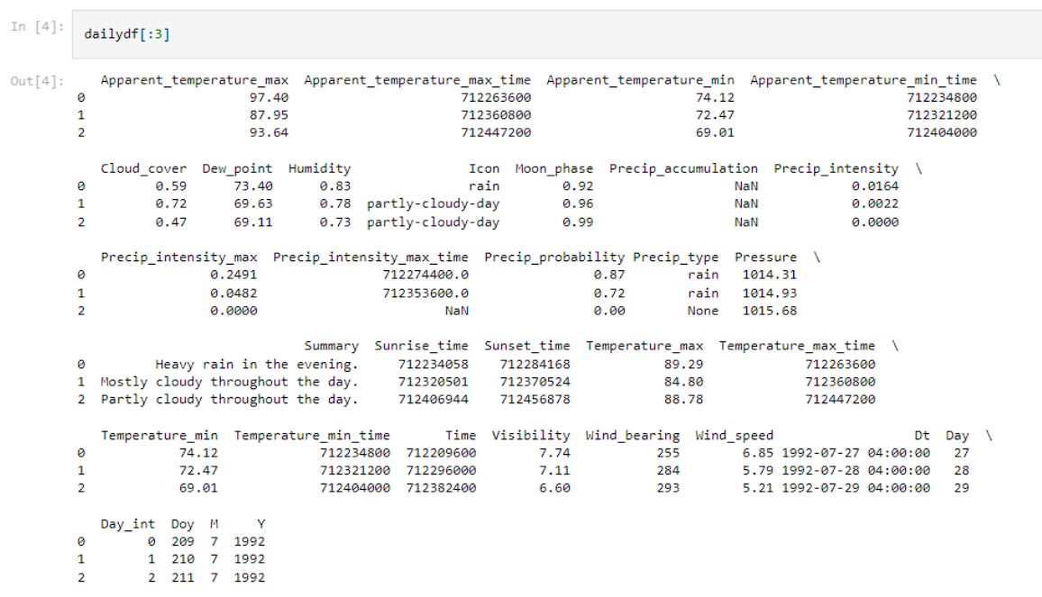

We used data to construct several variables that represented the initial pollen concentration circumstances. The processed data include a pollen flow, an averaged frictional velocity (u), a climatic correction factor (Ke), a characteristic concentration (C*), and a normal pollen distribution (Ce) (Fp). The three meteorological elements (temperature, relative humidity, and wind speed) that influence pollen release from plants are included in the meteorological adjustment factor, which indicates the resistance of pollen release depending on meteorological circumstances.

The adjustment factor's equation is as follows:

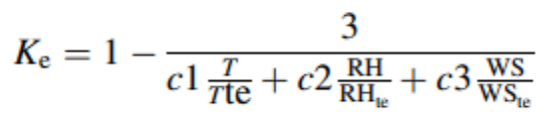

The threshold values for temperature, relative humidity, and wind speed are represented by the letters Tte, RHte, and WSte, respectively. From the threshold values of the most prevalent species in each group, we calculated the adjustment factor. Normal pollen distribution (Ce) simulates the seasonal pollen cycle for each category to represent the mean normal pollen distribution for each pollen vegetation group. Ce is defined as:

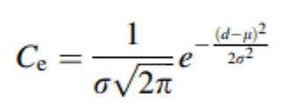

Where l is the mean distribution, r is the standard deviation for a normal distribution graph, and d is the number of days in a row that pollen measurements match or surpass the pollen count. Strong pollen variance in the time series made the appropriate statistical variables unsuitable. So, manually choose the l and r variables that best describe Ce's pollen trend throughout the years. The daily emission flux of pollen particles from each pollen vegetation type is known as the pollen flux (Fp). The pollen flux calculation is:

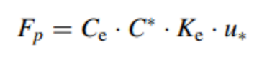

Where u* is the averaged frictional velocity, Ce is the normal pollen distribution, Ke is the climatic correction factor, and C* is the characteristic concentration. According to this definition, C* is:

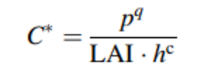

Where the term "canopy height" (hc) refers to the average height of the plant species. The LAI is the calculated mean LAI from MODIS satellite image data for the particular time period of the region surrounding the pollen station. We discovered that training the model with values larger than zero is more effective after doing several tests with the data.

Zero values may lead the model to disregard the data during training, resulting in fewer training sets. To avoid the model becoming a naive predictor, we added a value of 1 to the pollen count to decrease zero values in the data. The other input variables' significance is disregarded by naive predictors.

As a consequence, the model fraudulently generated good statistical findings by giving last day's pollen count more importance and utilizing it as its forecast. To lessen the magnitude differences between the various input data, we normalized all of the data. This prevents one feature from dominating over others or from drastically altering the weight matrix once the CNN model has been improved.

Even though it is superior to some of the weather data sources we tested, we still have to deal with some columns that have null values. Precip type and Precip accumulation are examples of simple ones.

It was a little more challenging to extract the nulls from the cloud cover. When we ran it through a decision tree, there were no clear patterns for when nulls would occur, so we quickly constructed a random forest model to utilize the other attributes to decide what should be entered in the Cloud cover rows that were missing. This imputation model's predictions on held-out data exhibit a fair degree of agreement with the actual values:

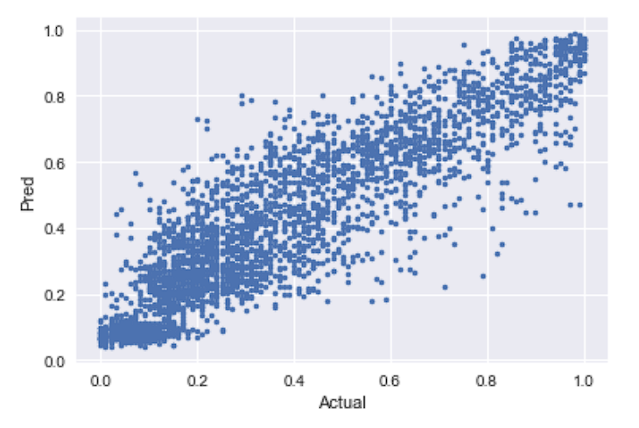

So we continued on and did it. However, the nulls don't seem to be distributed randomly (they looked to be connected with visibility and snow), so it would be useful to explore for a better solution later.

We modified the time characteristics (sunrise, sunset, maximum temperature, etc.) to represent the time of the day rather than UNIX time in addition to replacing the text category variables with dummy values.

According to my personal experience, the NAB categorization of the symptoms reflects the symptoms' nonlinear response rate to the pollen load. Here is a scale:

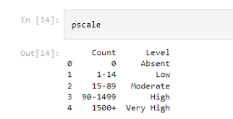

This tells the objective would be adequately described by the log of the pollen count because the symptoms increase with each order of magnitude change in the count rather than by a constant. Whether the actual count is in the low or high range, the traditional MSE would punish a forecast that is off by 50 in the same way, but modeling the log of the count would enhance the measure.

This is seen in the plot below. In contrast to the more equally scaled log plot on the right, the raw plot on the left displays a more radically shifting scale that would be more challenging to learn with a straightforward MSE loss.

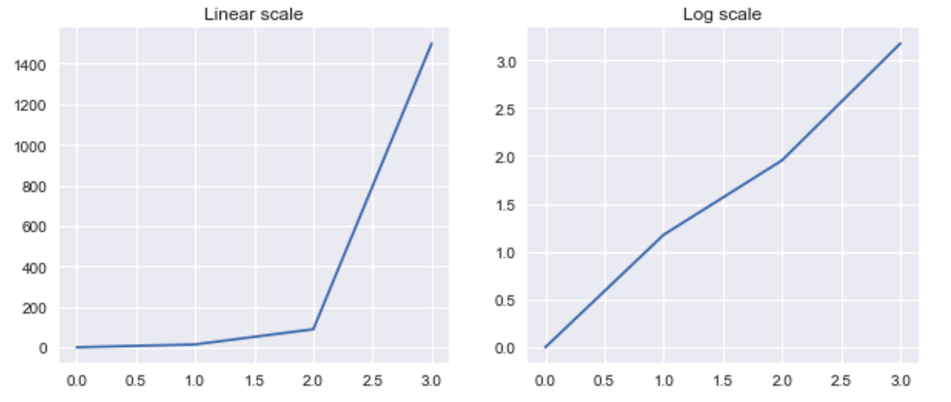

**Training:**

Many recommendations for RNN settings that are commonplace didn't seem to apply in this case. I have far less data, therefore the batch size remainders matter more, to start with. I utilize all of the entire batches with a batch size of 32 and a sequence length of 25 for the training set (4000 samples), and the leftover samples (about 400 samples) for the validation set.

I also discovered that fewer concealed units performed admirably. While employing only 8 units provided a respectable level of regularization in some conditions, 128 units was excessive and utterly overfit the data. For later-explained reasons, I chose a bigger number of units, but dropout helped avoid overfitting. To identify a decent set of hyperparameters, we utilized the Gaussian process optimizer in Skopt.

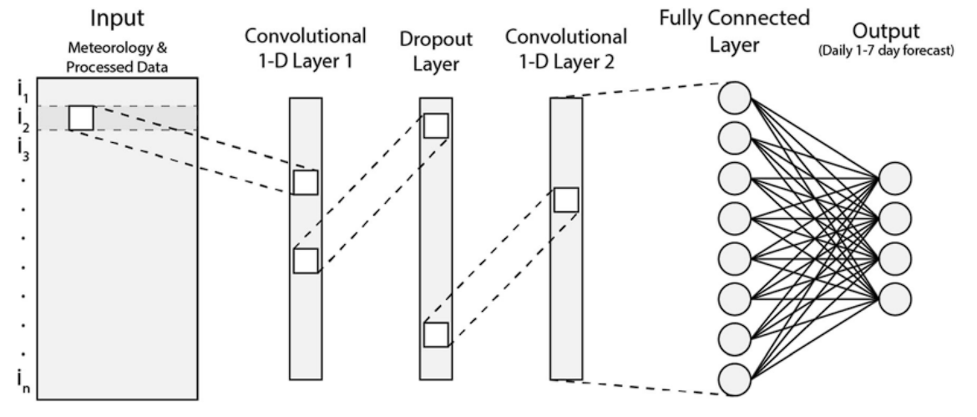

Here are some results for training and validation:

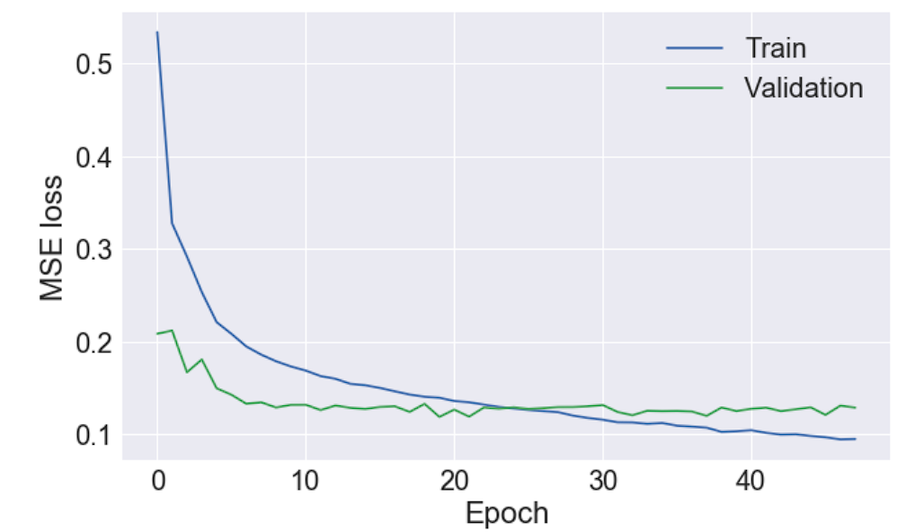

Here are some results for testing:

### 

### 

### Pollen Scout Hardware System

The direct to consumer product, Pollen Scout, is a low-cost pollen counting device which is AI enabled. Through the use of a reduced set of sensors and a neural network algorithm it will reduce the identification complexity as compared to traditional microscopy-based analysis of pollen taxa. In its early stages, the Scout will only be able to determine if a granule is pollen or non-pollen; however, through coordination with Pollen Base training datasets can be gathered quickly, easily, and correlated in order to make the Pollen Scout neural network smarter over time.

The preliminary pollen scout system diagram is shown below.

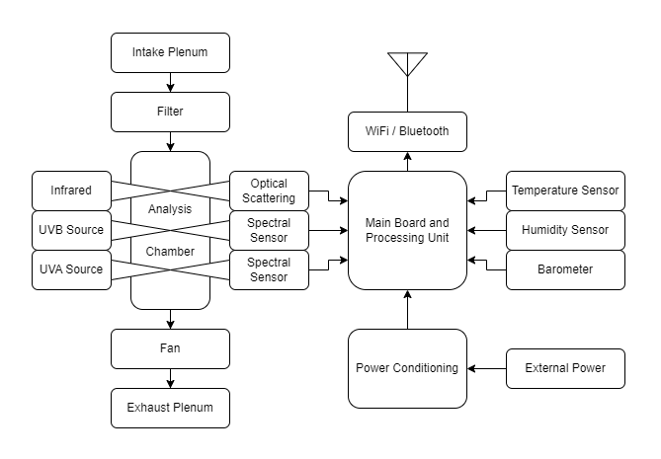

The Pollen Scout device hosts a suite of sensors aimed at analyzing incoming particles through an active airflow chamber. Drawing particles in with a fan, pre-filters exclude water ingress and over-size particles. Passing first by infrared optical sensors, scattering techniques are used to size the particle. Lastly, a pair of ultraviolet light sources will excite the particle and re-radiated visible light to be detected by band-pass filtered phototransistors; the multi-band outputs of which will be fed into a neural network which will provide a classification prediction. Reporting of the particle count and identification results will be sent via Internet Protocol via the consumers’ home network. For correlation purposes, onboard temperature and humidity sensors will supplement and verify publicly available weather station data. The rest of the data progression is described in the previous sections and through the AI model(s).

### 

### Pollen Base Hardware System

Behind the scenes, is the Pollen Base network of higher-cost counting and classification devices which use various microscopy techniques similar to current competitors on the market; the primary difference being that the Pollen Base will contain the same sensor suite as the Pollen Scout in order to provide AI training datasets that will one day enable better classification capabilities of the lower cost nodes.

The preliminary pollen base system diagram is shown below.

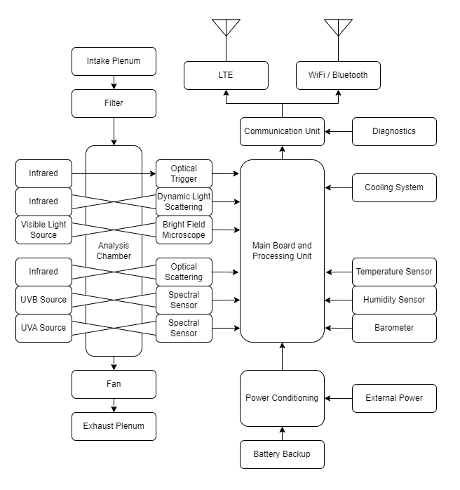

In addition to the same sensor suite as the Pollen Scout, the Pollen Base unit will have additional functionality enabling it to perform pollen tax identification and classification with accuracy >90%. The addition of bright field microscopes, a dynamic light scattering sensor, and holography devices will be utilized to achieve this high degree of accuracy. Since the Pollen Base is anticipated to be located in the same region as Pollen Scouts, it contains the same WiFi communication modules, and LTE wireless communication modules for placement in non-consumer locations.

### Pollen Data Cloud Application Framework

The data cloud framework dealing with pollen data serves three major functions. The first is the collection, correlation, and dissemination of pollen scout data, our initial primary product resource. Pollen data analyzed by the Pollen Scout device will be transmitted to a hosted cloud server (specific host TBD) via local wifi connection every ten minutes. This data will consist of the AI predicted pollen count and classification rendered on the Pollen Scout device using an embedded AI model. Count and classification data will be geolocated and time stamped upon submission. Once received in the cloud, the data will be correlated with local temperature and humidity derived from external source APIs to present a complete picture of localized airborne pollen.

Upon correlation, Pollen Scout data will be utilized in three ways. First, the data will be combined with all other collection site data to create a geographical heat map depicting pollen count and classification across regions, served to the Pollen ID application and web portal. Second, the pollen data will be sent specifically to the registered consumer where the device is located. The combination of these two data uses will enable the customer app health, welfare, and awareness experience. The third use of the collected pollen data will be storage in a repository database for bulk sale. Geo-tagged pollen data will be served to third party forecasting companies through business to business transactions. Data will be cataloged to allow for sale based on region, type of pollen, and time of collection.

The second major function of the pollen data cloud framework is to capture, analyze, and disseminate Pollen Base data. Collected Pollen Base data is critical in training the AI algorithm used on the Pollen Scout hardware. The Pollen Base will transmit both spectral and image data to the cloud via local wifi, collected every 10 minutes. Once received, geolocated, and time stamped, this data will be utilized to train the Pollen ID AI classification model using cloud services. Pollen ID will employ data labeling technicians to prepare data ingest for AI learning. We anticipate this being a significant and costly process but necessary to the overall data model employed. Using correlated spectral and image information, the AI model will continue to improve pollen count and classification by spectral sensor on the Pollen Scout. Updated AI algorithms will be distributed via wifi to Pollen Scout onboard computers for improved pollen analysis on a periodic timeline (TBD). In addition to feeding AI model training, data from the Pollen Base will also be added to the correlated geographic pollen picture and stored in the pollen data set for future sale.

The final major function of the pollen data cloud framework is to enable the management and storage of collected pollen data for future sale. We expect pollen collection data to increase in scale over time as additional systems are brought online. Pollen ID will employ data managers to ensure classification and organization is consistent as this volume increases. Data will be offered by geography, pollen type, and timeframe for sale via contract. Data managers will work with lead B2B customers to ensure data is structured in a way to be utilized in their native models.

### 

### Pollen ID Phone App Software Framework

The Pollen ID PhoneApp will communicate with the Pollen Scout device to get near real time updates device state and local pollen data from the install site. This local pollen data is also sent to the Pollen ID Cloud for further processing and the enriched data will be sent back to the app for consumption. The user will have an interface to input their personal information, location details and sensitivities that will be used to personalize their experience through alerts, suggestions or forecasting information they receive through the app. Personal information may be stored locally if the user opts out of sharing. The app will require login, security to authenticate the user and give access to the pollen data services.

### 

### 

### Technical Requirements Analysis

The Pollen ID team conducted an initial analysis of the proposed system against the specific technical requirements needed to fully realize the pollen sensing system as a whole. Note that the metrics utilized are spread across multiple devices and frameworks, and may be applicable to more than one attribute of the system as a whole.

Due to the large scope of the proposed solution, a vast majority of the parameters are subject to interpretation until such time as each sub-section of the system is fully prototyped and created. Upon such prototyping effort, a well established set of design parameters and system requirements will be generated for each sub-component of the system.

| Metric ID | Metric | Units | Pollen Scout | Pollen Base | Rationale |
| --- | --- | --- | --- | --- | --- |
| 1 | Pollen Identification | % | 90 | 95 | The model used has been demonstrated to result in 90% pollen identification accuracy and the accuracy is calculated as mentioned in the model description. |
| 2 | Pollen Classification | % | 85 | 90 | The model used has been demonstrated to result in 89% pollen classification accuracy and the accuracy is calculated as mentioned in model description |
| 3 | Air Suction Rate | cfm | 0.6 | 1 | The sensor captures data at 0.1ms. Around 1200 pollen grains per m3 would amount to 120ms (to capture data) with at least 3 second gap between 2 pollen grains in order to allow the sensor to come to a steady state. Therefore, the total time to record 1200 pollen grains is ~60 min; 1m3/hr ≈ 0.6cfm. We expect the base to be at least 50% faster than the scout. |
| 4 | Storage | MB/day | * | 250 | Calculated at 1200 images (average number of pollen grains on any given day) with 200 kb per image |
| 5 | Cloud Computing Speed | TFLOPS | * | * |  |
| 6 | CPU speed requirements | GFLOPS | 29.4 | - | As described by the AI model used |
| 7 | Forecasting Accuracy | % | 89 | 89 | The model used has been demonstrated to result in 90% forecasting accuracy and the accuracy is calculated as mentioned in the model description. |
| * = Cannot be determined as of now | | | | | |

### 

### Bill of Materials and Assembly Estimates

A parts and cost breakdown analysis was performed for the two device offerings (pollen scout and base) as shown in the tables below. Note that the analysis is only concerned with the physical construction, and does not account for other operating costs for deployment of the AI nodal network, such as server hosting or cloud computing necessary to fully realize Pollen ID’s holistic set of data services.

The analysis additionally presumes that production will be performed at scale with initial quantities reaching in the several thousands per year, reflecting a mature production process after initial device prototyping has been completed and validated.

|  |  |
| --- | --- |

### 

## Prototyping

### Prototyping Round 1: Hardware Design

Initial prototyping of pollen analysis involved the creation of a suitable platform in order to image using cheaply available USB microscopes, as well as a system by which to test UV fluorescence of pollen particles. As can be seen in the images below, modeling of the setup and prototyping in 3d printed plastic assemblies permit the capture of some initial images.

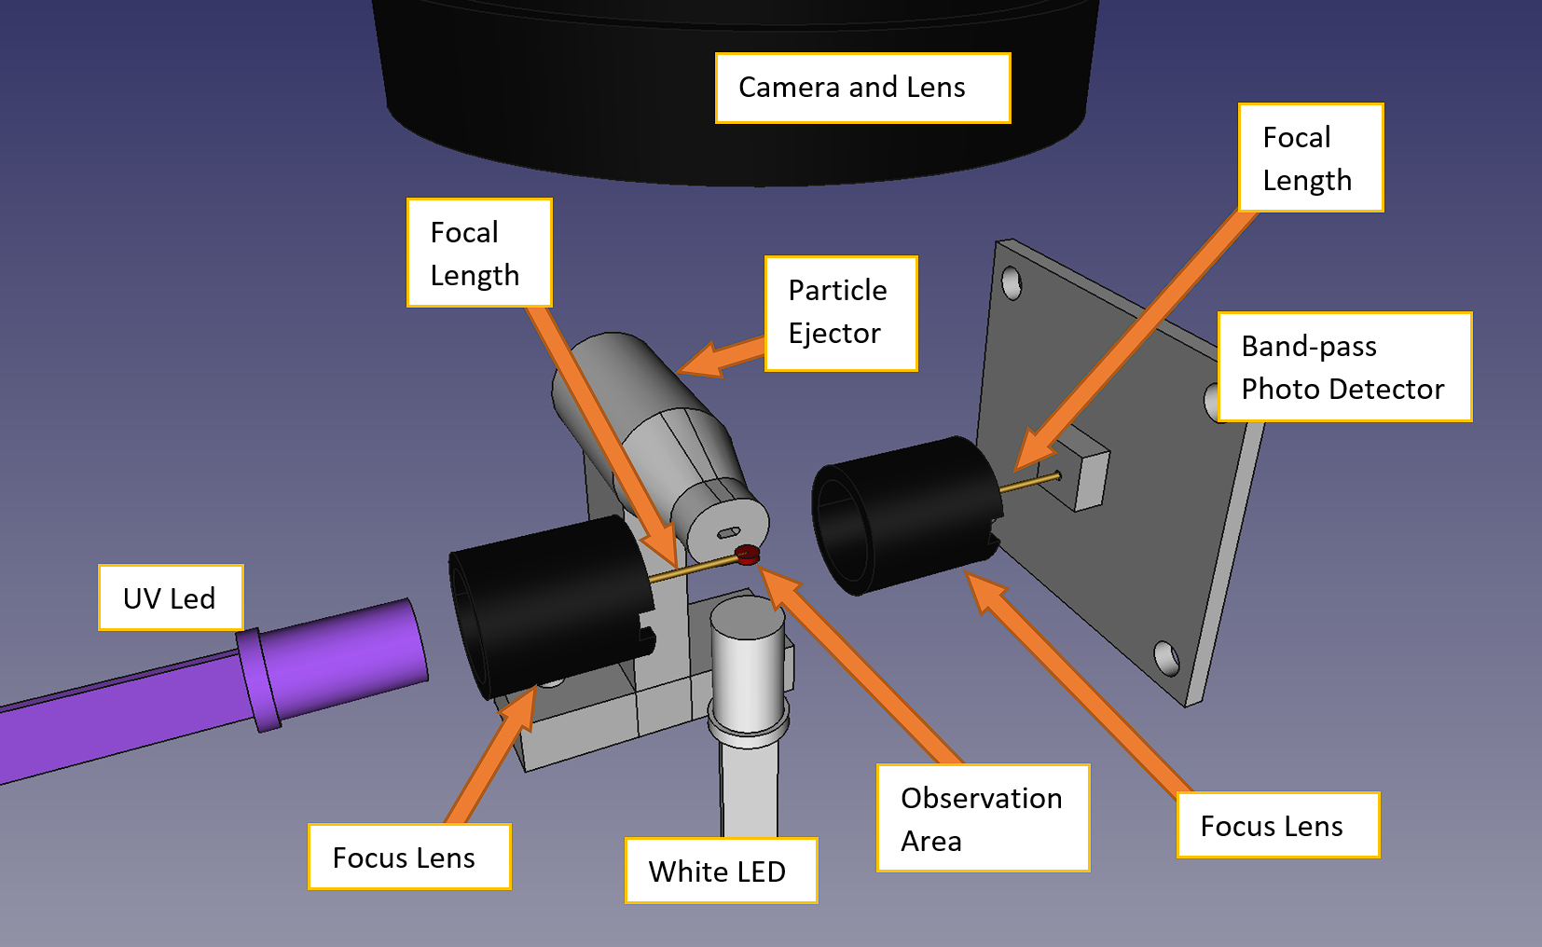

Of notable importance in testing was to try and image a particle in air. The initial design did not permit this as the required air velocity even to keep the pollen granule suspended and not fall out of air was too excessive and the camera would not be able to image the particle whizzing by at meters per second.

Backing off and trying to do elementary analysis with a fixed sample on a slide, the image below was produced when imaging a droplet of water containing collected bee pollen. This data will be used to test and prove out AI-enabled detection of pollen in an image.

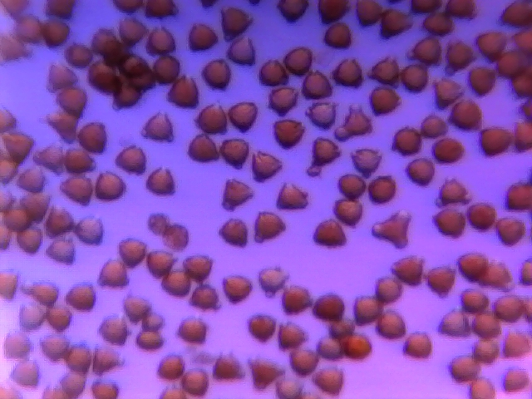

An quick alternative setup to prove the principle of pollen moving through a medium was utilizing water as a slow moving suspension fluid (setup depicted below). This proved to be much more controllable with much finer precision on flow rate. Several videos were recorded showing pollen grain steadily passing under the microscope objective.

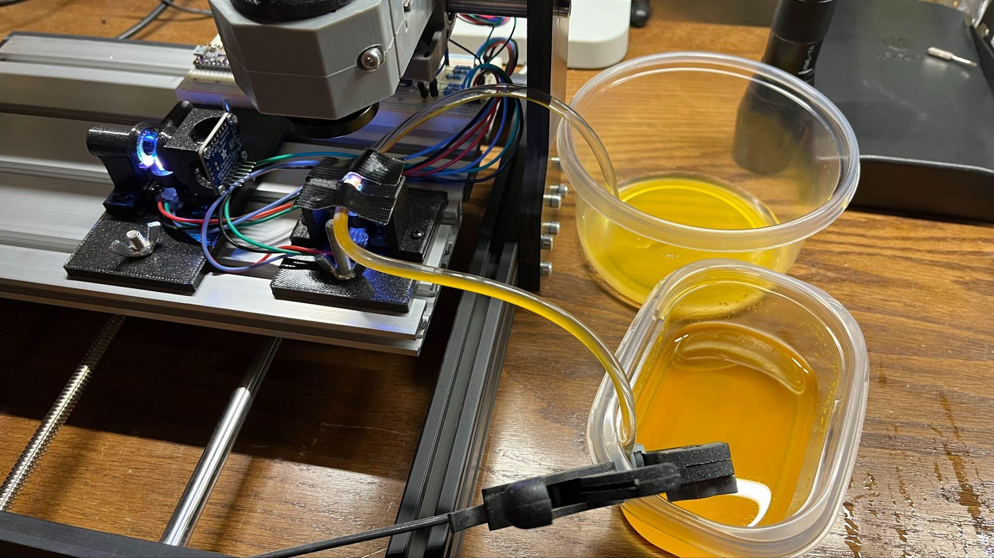

### 

### Prototyping Round 2: Computer Vision Enabled Counting

Upon completion of initial microscopy tests, the pollen images were imported into the Matlab environment for processing and proofing of computer vision models. As can be seen in the initial results below, still image processing has yielded some success with pollen particle identification. Application of the still-image script was then applied to video of constant flowing pollen through the PVC tubing setup (as shown previously) with marginal success. Note that this analysis is purely through image processing, and is not AI-enabled. This type of video processing can help greatly in object labeling processes which will be used to feed a full AI model.

| Still Image Processing Example | Video Processing Example |
| --- | --- |

From these experiments, we have validated that the initial engineering design can perform the basic operation of pollen particle separation from a background. Results can be further improved with a more standardized setup, with better microscopy lens and better/faster camera devices..

### Prototyping Round 3, UV Fluorescence Testing

**UV Fluorescence:**

The availability of inexpensive UV light sources along with a unique spectral pattern for a large variety of pollen taxa makes UV fluorescence a viable option for pollen identification and classification. After collecting and counting pollen, the next step would be to identify pollen. In order to test our lab setup for fluorescence, we shone UV light on pollen placed on a glass slide with the pollen grains facing the UV light. On the other side of the glass slide, we placed a sensor that completely covered the region of interest and could record the intensities of individual wavelengths in the scattered light. Using blue light as our control wavelength, we obtained significant differences in the intensities of the following wavelengths - 500nm, 550nm, 570nm, 600nm and 650nm. The differences between intensities will vary as the pollen type changes. This is due to the differences in size and shape of the pollen grains. Below is a plot showing the intensity differences for different wavelengths for the sample analyzed.

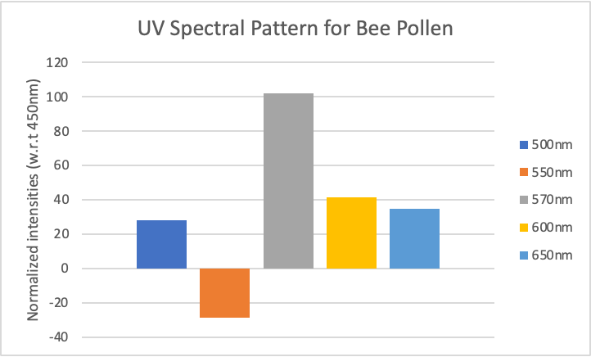

We expect to find similar differences for different pollen taxa as found in several research papers, showing the feasibility of this technique.

As mentioned previously, a color sensor was used to record the intensities of different wavelengths. This data would be sent to a microcontroller which would then display this data on the computer connected via USB.

The lab setup used is shown below:

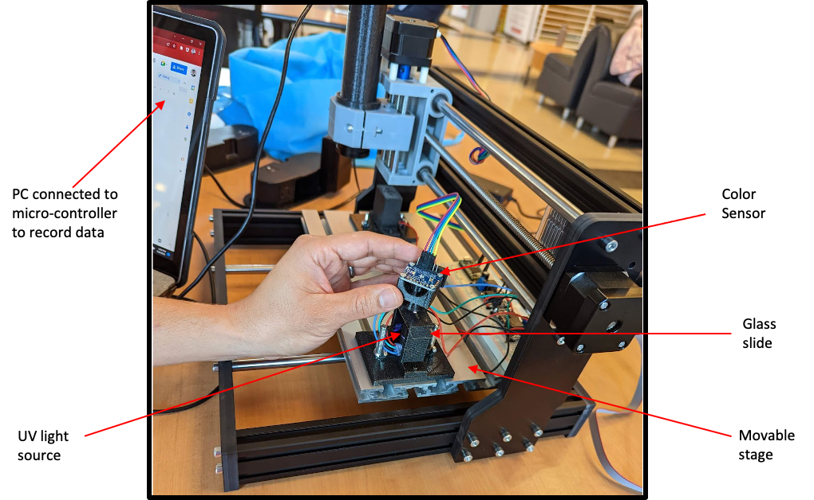

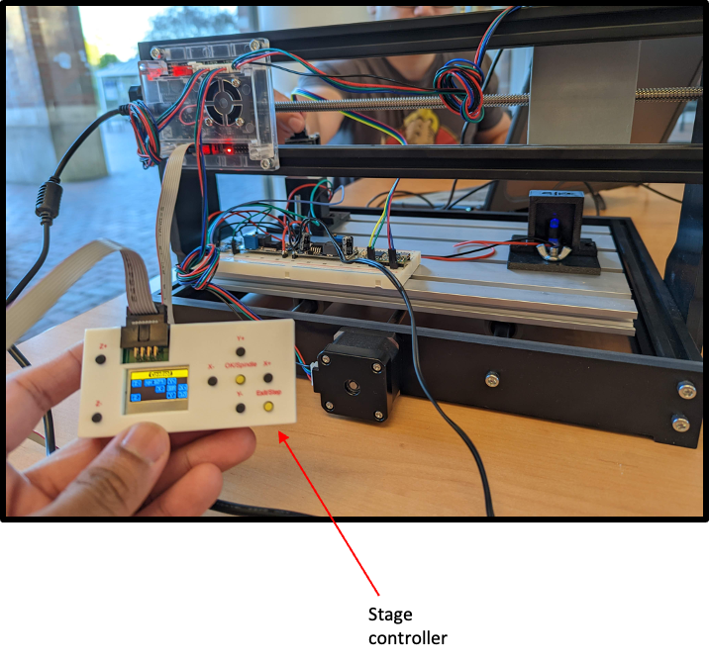

## 

## Engineering Risk Assessment

A typical risk assessment consists of the identification of risks, evaluation of its likelihood and severity, and identifying an action necessary to be taken in order to mitigate that risk. An example of a simplified risk matrix and the risk score is found in the chart below.



Through the technical development process and conclusion of initial testing and investigation, PollenID has identified a few key technical risks in the table below for the two product offerings, the Pollen Scout and Base. During the first phase of development of creating the PollenID products, the mitigation actions should be incorporated into schedule or cost as appropriate.

| **ID** | **Risk Statement** | **Likelihood** | **Severity** | **Risk Score** | **Solution/Mitigation plan** |
| --- | --- | --- | --- | --- | --- |
| **Pollen Scout** | | | | | |
| 1 | Designing an accurate and affordable pollen counter (Pollen Scout) | 3 | 3 | High | Use the best features from available competitors (with modifications) to minimize the risk of trying something entirely new. |
| 2 | Assembly of device | 3 | 3 | High | Considering the use of sophisticated components, its best to ship a pre-assembled product and we can outsource the manufacturing. |
| 3 | Maintenance | 2 | 2 | Medium | Through our research, we have found methods which have collected and analyzed a flowing air-stream for pollen. These devices need virtually low to no maintenance. Also, can introduce a timeline to produce the product. |
| 4 | Accurate Pollen Collection and faults in suction | 2 | 1 | Low | The device will use a suction pump to suck in a known volume of air. This is inspired by the ‘pollen sniffer’ which has shown good and efficient collection results. These pumps generally have a life of at least 3 years. |
| 5 | UV Source Problems | 2 | 2 | Medium | UV lamps usually last for 10000 hours. Operating for 6 hours a day would mean that these lamps would easily last for 4-5 years. In case of a blown out bulb, we plan on indicating that to the user so that the device can be repaired. |
| 7 | Color Sensor Problems | 1 | 3 | Medium | Any defects/problems in the color sensor will result in inaccurate pollen identification. The average life of a color sensor is 20 years. Thus, any problems in this sensor is pretty unlikely and can be mitigated by replacing the sensor. |
| 8 | Predicting pollen using AI algorithms | 3 | 3 | High | There is a high probability that the environment can affect pollen detection for example light and patterns in the graph and henceforth we can include more and more data with variable features. |
| 9 | Lag time for prediction wrt hardware (API) | 1 | 1 | Low | There is a possibility that due to hardware delivering the data to apps or websites there might be a time lag. |
| **Pollen Base** | | | | | |
| 1 | Deploying highly accurate pollen counting and identification devices (Pollen Base) | 3 | 3 | High | Initially use competitors’ tried and tested products to build a database and verify the accuracy of in-house made device |
| 2 | Camera Problems | 1 | 1 | Low | Digital cameras can really go on forever, unless they’re damaged by water (rain) or severe mechanical impact (device falling from a height etc.). The external enclosure will protect the internal components from all sorts of external damage and breakage. |
| 3 | Accuracy and correlation of weather data with collection | 3 | 2 | Medium-High | Higher data analysts to map the scope and requirements for correlating and tagging collected pollen predictions with geolocated weather. |
| 4 | Detecting pollen using AI algorithms | 3 | 3 | High | There is a high probability that the environment can affect pollen detection and henceforth we can include more and more data with variable features. |

## Final Design

### Mobile Device Application

A render of the PollenID mobile app login page is shown below. The sleek interface is aimed at providing subscription customers access to the paid service data as well as the data directly from the Pollen Scout (if purchased and linked to their account).

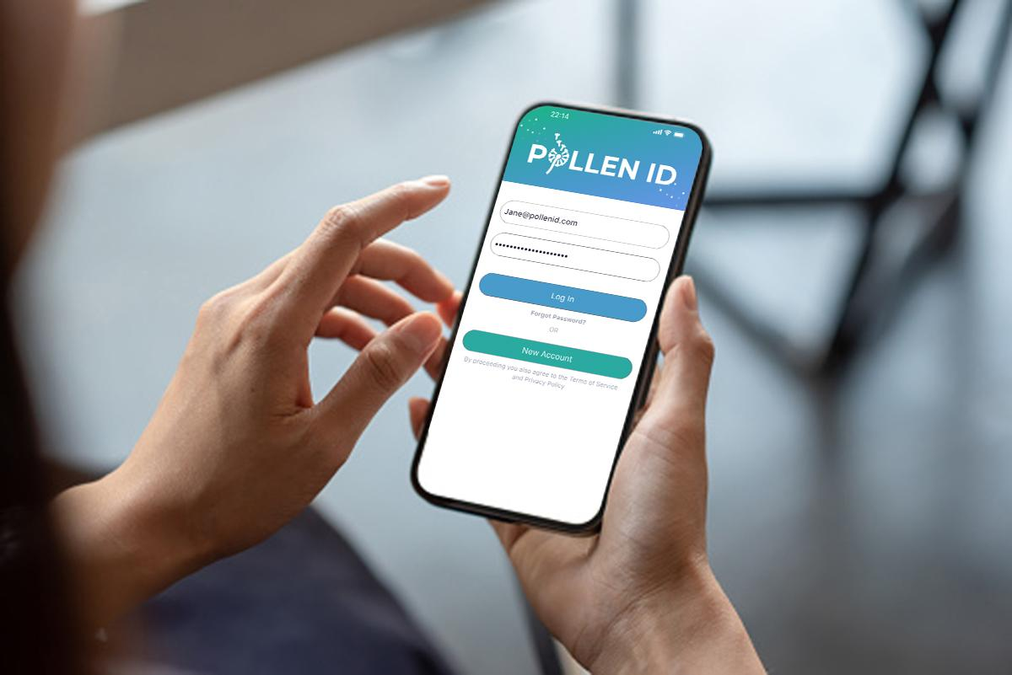

A list of the various features of the proposed PollenID phone application is listed below:

* Pollen data
  + Live localized pollen count
  + General local pollen forecast
  + Pollen data on-the-go
* Personalized allergen forecast
  + Automated allergy health check-ins
  + Reminders and alerts
  + Allergy summary insights

Renders of the various user interface pages are shown below as an example of the user interface look and feel. From left to right, the following descriptions provide a little more context:

* **Left:** Users can optimize their experience by inputting specific information with regard to their individual pollen allergies and sensitivities. This information will be used to filter incoming pollen forecast data and provide alerts, if established by the user.
* **Center left:** Users will see personalized suggestions/tips based on their inputs and the current pollen count. They will get insights on how others in their area with similar allergies are feeling and will be able to make decisions based on hourly forecasts.
* **Center right:** The power of tracking symptoms means that the application can provide insights that our customers may not already know. If a user believes they are sensitive to ragweed, we can help verify that, or point out that there may be some other allergen sensitivity that they were previously unaware of.
* **Right:** Live forecast data, coupling weather and pollen all in one display. 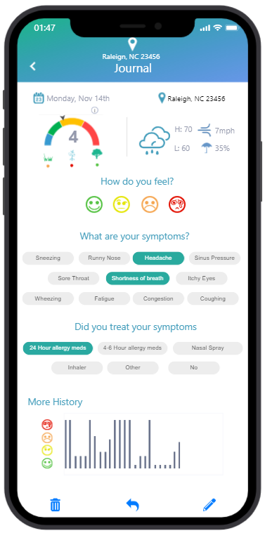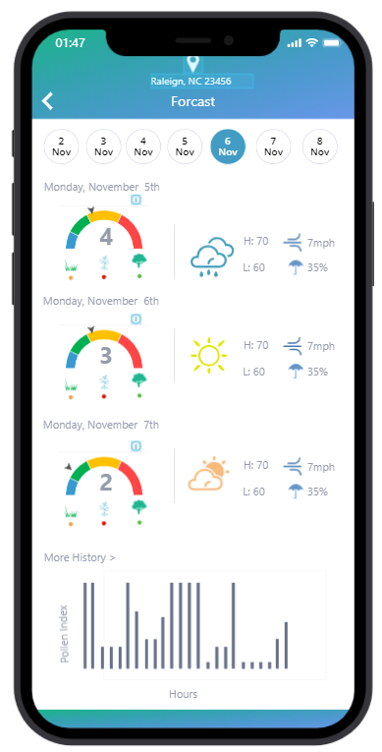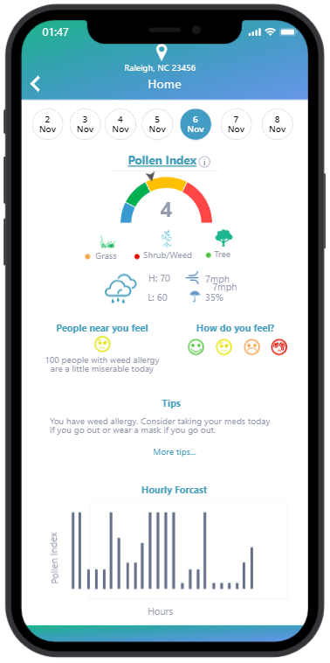

### 

### Pollen Scout Device

The pollen scout device rendering is shown below. The physical design is a small portable, battery powered device, intended to be installed easily by the customer. Setup and connecting the unit to the user's wireless network will enable the user to gain access to direct data.

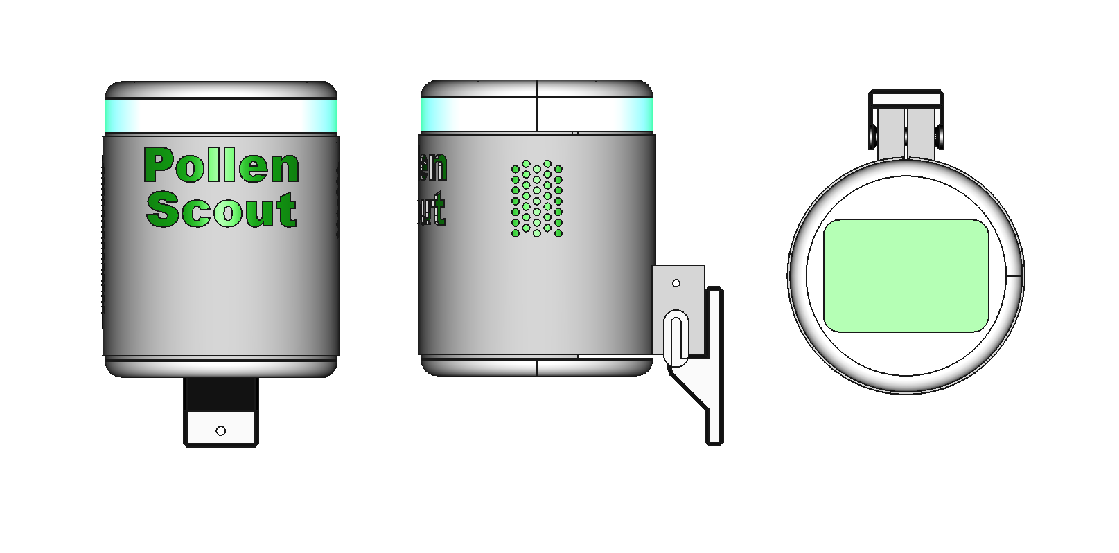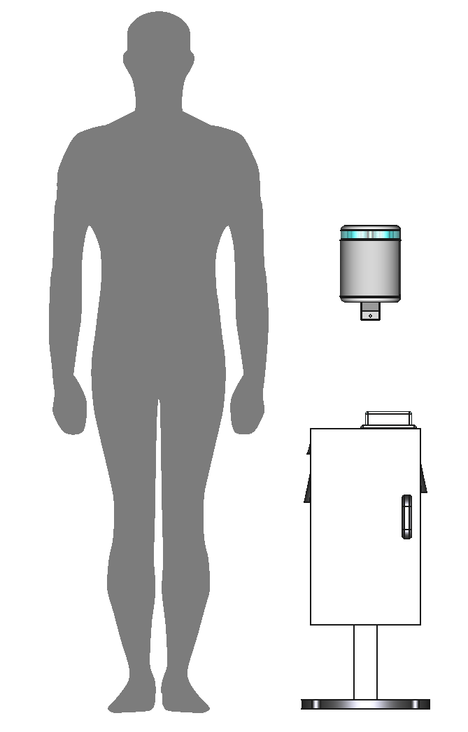

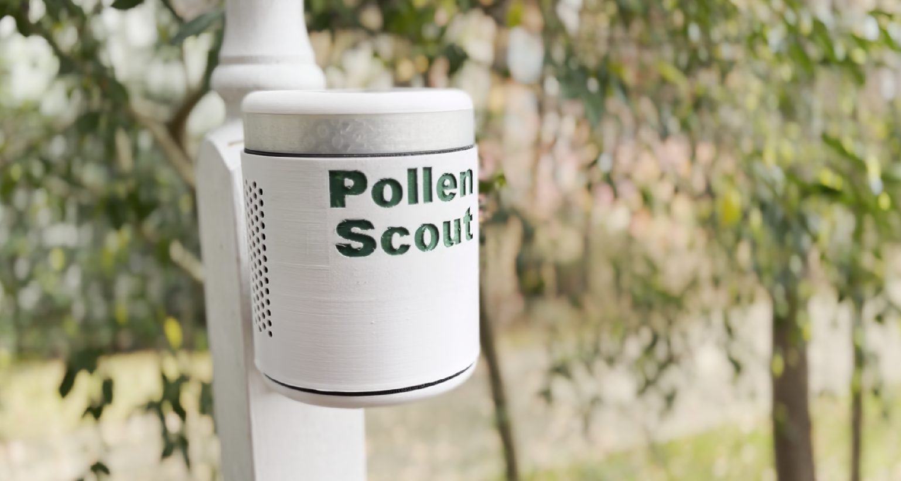

An itemized list of the primary user features is as follows:

* Portable, battery powered, solar-rechargeable
* WiFi enabled
* Automatic reporting and alerts
* Low to zero maintenance
* Easy to install and setup

The internals of the prototype is shown in the diagram below. Refer to the system architecture diagrams provided previous to see how the device is intended to operate. The highlights of this design is the ability to provide pollen counting capabilities utilizing low cost UV fluorescence emitters and sensors, coupled with a neural network algorithm trained and validated through the cloud application framework of Pollen ID services.

It is known that the fidelity of the UV fluorescence measuring technique cannot provide the level of classification accuracy as a direct imaging solution, however, it will provide a basis of highly accurate binning between groups of pollen taxa and non-pollen particles. This information is highly valued, and will be supplemented by the more powerful Pollen Base device.

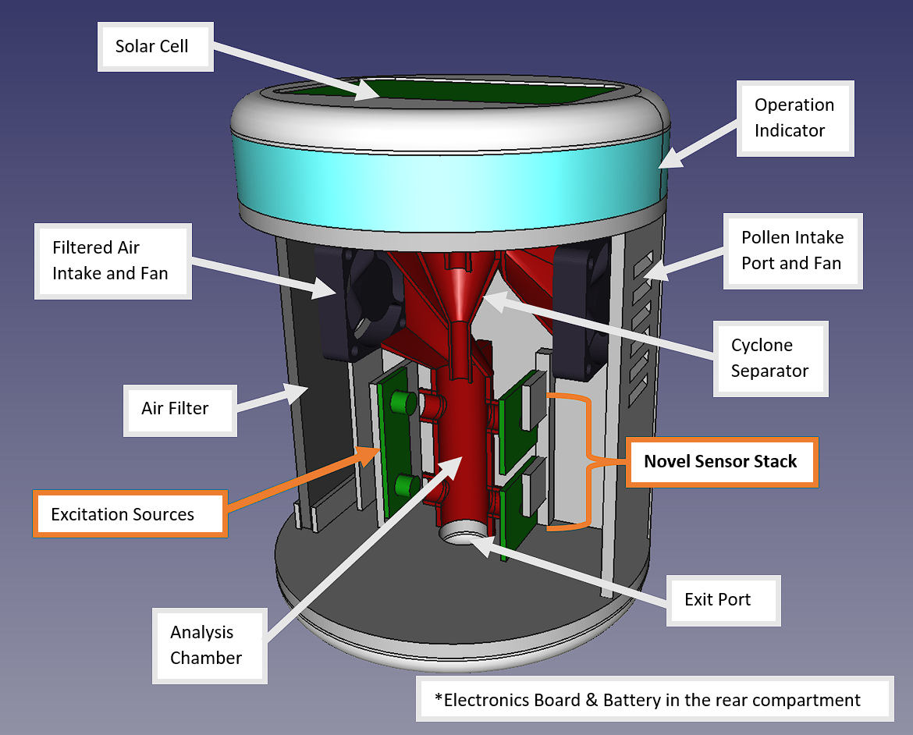

### 

### Pollen Base Device

The pollen base device rendering is shown below. The physical design is an installable device, intended to be installed at fixed locations and utilized as a hub within a network of Pollen Scouts.

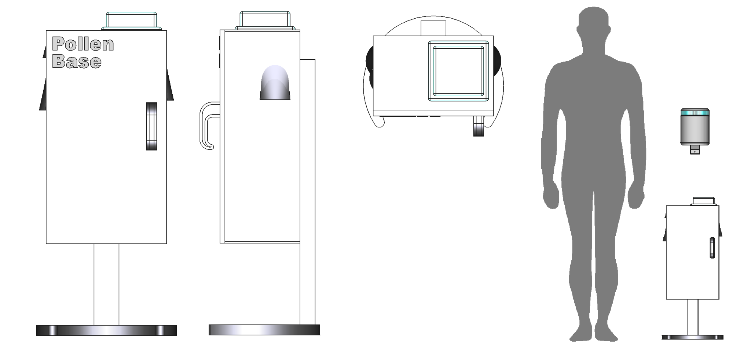

An itemized list of the primary user features is as follows:

* Medium Cost
* More accurate data
* AI counting enabled

The schematic below shows the prototype's internals. For an overview of how the device is supposed to function, review the system architecture diagrams previously supplied. The ability to deliver pollen counting capabilities using cyclone separator, analysis chamber, inexpensive UV fluorescence emitters and sensors, together with a neural network algorithm taught and verified using the cloud application architecture of Pollen ID services, is one of this design's key features. The other critical component is the addition of optical imaging sensors that image pollen at less than one millisecond intervals.

Although it is well established that the UV fluorescence measurement method's fidelity cannot offer the same degree of classification accuracy as a direct imaging approach, it will serve as a foundation for extremely precise binning between groups of pollen taxa and non-pollen particles. The direct imaging capability of Pollen Base allows for comparison and correlation to be done with UV sensor outputs. Pollen Base has more computing power to process more complex information compared to Pollen Scout, which is required for the additional imagery capabilities. Outputs of this information is sent to the Pollen Cloud for UV AI model training to increase the accuracy of Pollen Scout outputs.

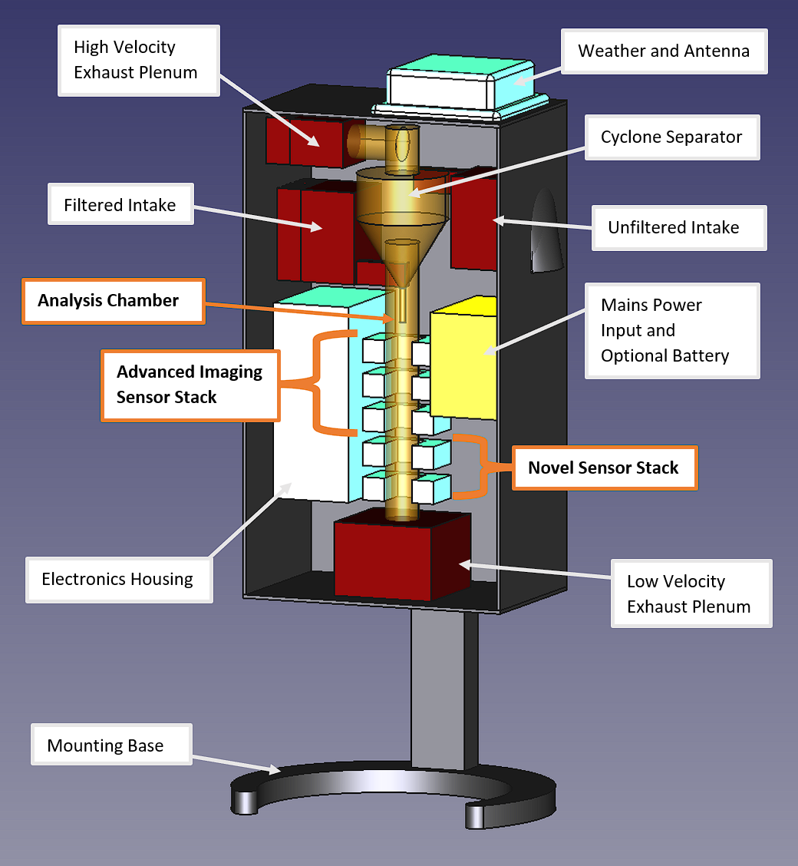

# 

# VALUE PROPOSITION AND BUSINESS MODEL

## Business Narrative

**Key Business Goals**

Our primary business goal is to develop a combination of hardware and software solutions that provide geographically accurate, real-time pollen counts and classifications for allergy sufferers. Current pollen counting solutions require expensive equipment that is resource intensive, have time consuming procedures, and require an in-depth knowledge of taxa identification and manual pollen counting. To address these issues, we will create a more affordable device, targeted to a larger consumer base, to feed a crowdsourced pollen database and use an AI prediction model to provide more accurate local pollen information and enable better personal health decisions by individuals.

Hardware

Develop a new pollen counting device, driven by AI systems to increase counting speed, better categorization, lower error rates, with lower maintenance requirements. This new device will aim to deliver on these goals at a lower operating cost compared to existing counting systems and procedures, permitting the deployment of a greater number of sensors for finer resolution pollen data. These “scout” sensors will be complimented by “hub” sensors that are more precise in pollen species classification to which data can be correlated for more accurate pollen information at scout collection sites.

Software

Development of AI models capable of properly identifying and correlating pollen taxa, separating false positives from other materials. With a large enough pollen counting data set, advanced algorithms will seek to correlate weather and other data to provide predictive pollen forecasting of key pollen.

Deployment

Less expensive pollen scout devices are designed to be deployed at individual households, local businesses, or city buildings. Hub systems are designed to be placed at more centralized collection sites, similar to cell phone tower locations. Collection by the more advanced hub devices will compliment the pollen counting data from scout devices in AI enabled correlation analysis. New pollen data, rendered with classification predictions will be delivered via wifi to end users through a mobile application.

## Target Market Segments

With these few simple facts in mind, our business strategy is directed towards a tiered development approach:

* **(Primary) Pollen Dataset Collection** - Segments: Weather Forecasting Health and Society Services, Water and Air Quality Testing Indoor Air Quality. Current allergy prediction models are limited in fidelity by a lack of geographically relevant pollen data. Existing pollen counting methods used by governments and private companies are too few in number, outdated, slow, and costly. We seek to revolutionize pollen counting with AI-enabled, low maintenance devices that can be deployed to a greater number of sampling locations with a direct to consumer device. Initial units will be IoT enabled, providing a repository of geographically specific pollen data for use in organic predictive products or sale to weather forecasting services.
* **(Secondary) Pollen Predictions/Forecasting** - Segments: Weather Forecasting, Allergy Treatment and Drug Development. Current forecasting efforts lack fidelity due to poor pollen data collection (Ref. 3). Feeding off a new larger data set as sensor integration is more widespread, data correlation of pollen counting and weather data can provide even more accurate predictions of a pollen forecast. Furthermore, partnering with allergy medicine companies, smart device applications can provide users with personalized pollen alerts timed with their particular sensitivities and prescription timing requirements. Organically created AI forecasting models will be designed to be delivered directly to individual users via a product mobile application. Additional target customers will be healthcare conglomerates, private practices, and insurance companies tied to public health. These entities can use our forecast to make appropriate business and treatment decisions in multi-billion dollar markets. Partnerships with pharmaceutical companies will enable product delivery to greater numbers of customers. Secondary markets will be data sales or partnerships with weather forecasting companies that utilize existing models, enhanced with our pollen dataset.
* **(Secondary) Agriculture Produce Health**: Segment: Fruit and Nuts. Pollen data collection and AI training is expected to improve pollen grain analysis in low cost collection devices over time. As our capabilities develop, we intend to target fruit and nut farmers for application of pollen collection and analysis to predict harvest yield, quality, and health in flowering crops.

## Value Propositions

For the 25 million severe allergy sufferers in the United States, who require affordable, geographically accurate and timely pollen information in order to make critical health decisions, we offer the Pollen ID Integrated System that provides real-time pollen information tailored to each user, saving over $5,000 in annual medical costs and countless hours of lost productivity due to illness. Unlike other collection companies, the Pollen ID Integrated System uses a hub and spoke method of low maintenance, at-home pollen counters, combined with advanced AI to provide real-time allergen classification through a convenient mobile application. Our system scouts the airborne pollen directly impacting the individual, enabling them to take precise healthcare actions required to stave off chronic illnesses triggered by severe allergies.

# GO-TO-MARKET LAUNCH STRATEGY

## Go-to-market Approach

Pollen ID’s is a startup company with innovative hardware and software products that will primarily serve allergy sufferers. Pollen Id’s products fill key gaps in current offerings: Limited data collection which has led to lack of trust in current solutions and lack of personalized solutions for consumers to manage their individual treatment and symptoms.

Introducing a new product to the market will require a lot of advertising to promote and increase awareness of our products. We plan on hiring a marketing analyst and implement a digital marketing strategy. Digital marketing is less expensive and effective when targeting specific audiences. We plan on introducing our products one region at a time starting with Raleigh, Wake County, and digital marketing will allow us to only focus our marketing efforts on potential customers within Raleigh since our products will not yet be available in other regions.

Pollen ID’s go-to-market strategy is divided into 3 phases over 5 years and see us expand to over 10 regions across the south-east which is considered the most biodiverse region in the US which will provide rich data and consumer market. We anticipate capturing 0.5% of the regional population for each additional market.

**Phase 1:** We are targeting a pilot deployment of 100 Pollen Scout units and 10 Pollen Base units across the triangle area covering Raleigh, Durham, and Cary in North Carolina. This pilot is critical to collecting the initial data set needed for train our AI model and validate our internal product assessments and targets. Consumers will receive a Pollen Scout device and access to our phone app that is delivering hyper localized, near real time pollen data and insights.

As identified in our voice of customer research, those with severe symptoms are more likely to rely on pollen data for treatment. We may partner with local allergists & immunologists to ensure these devices are deployed to the consumers who are considered to have severe symptoms.

**Phase 2:** After the AI model has been trained and we have positively assessed all key targets, our next targets are 0.5% of Wake County to deploy 5000 Pollen Scout units and 20 Pollen base units. In year 1 we have 5% (~$60K) of revenue budgeted to market the Pollen ID brand and products. There are several channels Pollen ID will take to create brand recognition locally.

1. **Expand local Immunologist and allergist partnership network:** Research also indicated that allergists and immunologists typically provide treatment based on individualized treatment plans and environmental avoidance. It would be ideal to partner with multiple local providers that may refer Pollen ID solution as an option if consumers want to incorporate Pollen information into their treatment plan

2. **Events and networks:** We will look to engage in events such as the NC Allergy, Asthma, and Immunology Society (May 19-21, 2023) to help get feedback and create awareness.

3. **Search, Communities & social media:** Our voice of customer research indicated pollen data consumers often get their information and engage through an app, communities, and social media. We intend to leverage this channel to connect with consumers and through social media campaigns to market the pollen ID brand and products. A modest campaign will include 4 networks (e.g., Facebook, Twitter, LinkedIn, and Instagram) with up to 45 social posts per month, with content monitoring is estimated at $2050 per month.

In parallel we will also run google search campaigns to highlight our brand. We will also run search Ads (Google Ads) targeting 5000 impressions with a daily budget of $166 ($5K per month)

4. **Radio Ads** – with a focus on the local Raleigh market, the radio offers a cost effect method for introducing Pollen ID to a broad audience. A modest radio ad will cost up to $5K per week ($20K per month).

**Phase 3 and beyond:** Once we have established some trust in our products and services, we can aggressively expand growth of market share and sales in 20 markets across the southeast region and reach 1.5% of the respective populations. This would result in over 200K units of sale for Pollen Scout and over 800 units for Pollen Base. Based on projections we would have an increased marketing budget of $2M.

This funding would allow a broader digital marketing strategy and radio ads across the Southeast region with the option to incorporate a modest 30 second local cable & TV Ads which can cost between $20K – $100K based on viewership. We also anticipate marketing pollen to local governments and institutions and ultimately global expansion into European markets.

## Pricing Strategy

The pricing strategy for our product is penetration pricing, which is based on providing the products at a low initial price and increasing price overtime. This strategy is in line with our initial short-term market goal, which is to gain customer attention, increase product awareness and sell as many pollen scouts as possible in the first two years which in turn will help us to collect more pollen data and improve our AI model accuracy and prediction. We will offer 3 products:

**Pollen Scout:** which is priced at $255, While there are currently no competing consumer products, and we have pricing power, this device is modestly priced based on research and in line with the cost of doctor’s visit or an allergy skin test.

**Pollen Base:** is yet to be priced pending further analysis, however, the cost of construction is approximately$950 (80% cheaper than closest competitors PollenSense) without consideration of additional cost and profit margins.

Once we have achieved market penetration targets, we can leverage mass manufacturing and economies of scale to further improve production costs and improve margins.

## Distribution Strategy

During our phase 1 we are targeting a minimum 100 units distributed either through direct-to-consumer sales through Pollen ID’s website and leverage USPS for low-cost shipping services to consumers for sales through the website. Additionally, we will work with our partner allergist and immunology offices to give our Pollen Scout device for free to severe allergy sufferers as part of a promotion. Our Pollen Base will be deployed at no cost to consumers to support the enrichment of pollen data in the pilot phase.

In phase 2 we expect to bolster our digital marketing (social media and search) and direct-to-consumer model for organic growth to reach our sales target of 5,000 units of Pollen Scout. We expect to increase distribution via reference through our Allergist and Immunologist network and look to partner with pharmaceutical companies to distribute to potential customers.

In Phase 3 we anticipate expansion through several locations in the Southeast region and will need to tap into additional distributors like Home Depot, Lowes, and Amazon Marketplace to achieve our target of more than 55,000. We will also need to expand the shipper network by onboarding UPS or FedEx.

## Marketing Tactics by Segment

The pricing strategy for our product is penetration pricing , which is based on providing the products at a low initial price and increasing price overtime. This strategy is in line with our initial short term market goal which is to gain customer attention , increase product awareness and sell as many pollen scouts in the first two years which in turn will help us to collect more pollen data in the long run. Additionally, we believe that testing the waters with new products by offering them at low price will drive growth which will help us achieve our long term of increasing market share.

Introducing a new product to the market will require a lot of advertising to promote and increase awareness of our products. We plan on hiring a marketing analyst and the marketing strategy that we feel is a good starting point is digital marketing. Digital marketing is less expensive and effective, we can reach a large population through online advertising. WIth digital marketing, we will be able to target users that are more likely to respond to our marketing campaign instead of targeting the entire population , this will save us time and marketing costs. It is important to target specific customers because we plan on introducing our products one region at a time starting with Raleigh, Wake county, and digital marketing will allow us to only focus our marketing efforts on potential customers within Raleigh instead of targeting the entire country especially since our products will not yet be available in other regions. We plan on expanding to other regions such as southeast regions in the second year by introducing our products to ten more regions reaching 0.5% of regional population for each additional market.

As stated previously, our distribution channels will shift as we progress from phase to phase. Initial distribution will exist through online sales via a direct company website. Access to customers will be restricted initially in order to ensure system integrity based on the regions of operation we have set up. This starts with Raleigh but will grow across the southeastern United States. Customers in our selected regions will be directed to the website through social media and local commercials and click rates will be monitored. As the Pollen ID system architecture becomes established and additional regions are selected for growth, delivery channels will increase to home improvement retailers and pharmacies. As we experience regional growth, partnerships with retailers will adjust to place hardware in the most accessible locations that fit with the Pollen ID brand. All Pollen ID users will find their app through mobile stores and receive Pollen ID data direct to their devices. Upon sufficient growth in hardware deployment, Pollen ID will open delivery channels to weather and air quality forecasting companies through direct, contracted sales of pollen data. Finally, Pollen ID will seek partnership opportunities with allergy medication manufacturers to broaden product channels and share marketing costs.

## Initial Roll-Out Strategy

As highlighted in our marketing and distribution strategies, our first customers will be severe allergy sufferers located in the city of Raleigh. We assess that a reasonable target number of customers is .05% of the population, which is significantly less than our initial research has determined would be willing to buy a device. Initial customers will be sold the Pollen Scout home monitoring device, which will be complemented with the Pollen ID mobile app. Marketing to these individuals will be primarily through social media. Our research has found that a large portion of severe allergy sufferers are active in allergy blogs and follow existing pollen information distribution sites.

# FINANCIAL ANALYSIS

## Product Cost Analysis

Our products are categorized into three categories: pollen scouts, pollen base and pollen data. The pricing strategy for our products is penetration strategy whereby we initially price our products very low to gain market share, customer attention and products awareness, and then raise price overtime. This strategy was chosen based on the fact that our long-term goal is to eventually have as much pollen data as possible, and selling more pollen scouts allows us to collect more data. Below table 1 and table 2 show the pricing breakdown, our target profit for pollen scouts is $55 per unit and unit price is $255.71 while unit cost is $127.65. Other costs considered are distribution costs. For Pollen Base, cost per unit is $825 while price per unit is $948.75 at zero profit .

**Table 1. CONSUMER UNIT /POLLEN SCOUT PRICING ANALYSIS**

| **CONSUMER UNIT COSTS SUMMARY** |  |
| --- | --- |
| Fixed costs | $81.00 |
| Variable Costs | $30.00 |
| Total costs per unit | $111 |
| **MARGIN OF ERROR %** | 15.00% |
| **MARGIN OF ERROR TOTAL** | $127.65 |
| **PROFIT** | $55.00 |
| **MFG SUB-TOTAL** | $182.65 |
| **DISTRIBUTOR SHARE %** | 40.00% |
| **DISTRIBUTOR SHARE $** | $73.06 |
| **RETAIL TOTAL (MSRP)/ COST PER UNIT** | $255.71 |

**Table 2. POLLEN BASE (ADVANCED UNIT) PRICING ANALYSIS**

| **ADVANCED UNIT COSTS SUMMARY** |  |
| --- | --- |
| Fixed costs | $585.00 |
| Variable Costs | $240.00 |
| Total costs | $825.00 |
| **MARGIN OF ERROR %** | 15.00% |
| **MARGIN OF ERROR TOTAL** | $948.75 |
| **PROFIT** | $0.00 |
| **MFG SUB-TOTAL** | $948.75 |
| **DISTRIBUTOR SHARE %** | 0.00% |
| **DISTRIBUTOR SHARE $** | $0.00 |
| **RETAIL TOTAL (MSRP)/ COST PER UNIT** | $948.75 |

## Marketing and people costs

The marketing costs are assumed to be 5% of the total revenue . We plan on using digital advertising with a short term goal of boosting pollen scouts sales, while the long term goal is to increase the awareness of pollen data, pollen base and pollen scouts, and to consistently generate 20% new customers over a period of five years. Digital marketing is relatively cheap and will require one employee, a marketing analyst, therefore it is the best option for us at least for the first five years since we are aiming at minimizing costs. The digital marketing channels that we plan on using include social media ads, online advertising with pay-per-click ads and search engine optimization.

For the people's costs, we plan on outsourcing manufacturing and hiring 8 employees for the first five years, and below is a table of employees we will have to hire within the first five years and their approximate hourly pay.

**Table 3. People Costs Analysis**

| **People Costs** | **Average Hourly pay** | **Average Yearly Pay** | **Year 1-Year 4** |
| --- | --- | --- | --- |
| Database manager | $33.65 | $70,000.00 | 70,000.00 |
| AI data labelers (2) | $39.42 | $82,000.00 | $164,000.00 |
| Logistics manager | $48.08 | $100,000.00 | $100,000.00 |
| Marketing Analyst | $33.65 | $70,000.00 | $70,000.00 |
| Hardware Developer | $48.08 | $100,000.00 | $100,000.00 |
| AI developer | $57.69 | $120,000.00 | $120,000.00 |
| App Engineer | $33.65 | $70,000.00 | $70,000.00 |
| Total costs | $294.23 | $612,000.00 | $694,000.00 |

## Profitability Analysis and Revenue Projections

Our profitability model is a four year projection and the total profit at the end of the fourth year is projected to be $22 Million. For the first two years there will be no revenue from pollen base and pollen data because during those initial years we are aiming at gathering and processing as much pollen data as possible. In the third year, we are expecting to start selling Pollen Base as well, until then most of the revenue will come from pollen scouts sales.

We estimated year 0 to be an experimental and development year with a sunk development cost that leads to a loss of $52,765. In year 1, we are limiting pollen scouts sales to one region which is Raleigh region and we are expecting to reach 0.5% of Wake county population, approximately 5000 people. In year 2, we plan on expanding to 10 regions in the South-east reaching 0.5% of each additional market. We choose the South-east first because biodiversity is greater in the South-east than anywhere else in the USA. In year 3 and year 4 we plan on doubling the growth in the 10 additional markets each year, approximately reaching 1.5% of the regional population in year 3 and 3% of the regional population in year 4. We estimated that there will be 1 pollen base per 250 pollen scout users from year 1 to year 4.

**Table 4. Four Years Revenue Projection**

|  | **Year 0** | **Year 1** | **Year 2** | **Year 3** | **Year 4** |
| --- | --- | --- | --- | --- | --- |
| "Pollen Scout" Units | 100 | 5000 | 55000 | 100000 | 200000 |
| "Pollen Base" Units | 10 | 20 | 220 | 400 | 800 |
| "Pollen Scout" Cost Per Unit | 127.65 | 127.65 | 127.65 | 127.65 | 127.65 |
| "Pollen Base" Cost Per Unit | 3,000.00 | 825.00 | 825.00 | 825.00 | 825.00 |
| AI Cloud Computing Cost | $10,000.00 | $20,000.00 | $40,000.00 | $80,000.00 | $160,000.00 |
| Marketing Costs (5% of Revenue) | $0.00 | $63,927.50 | $703,202.50 | $1,312,525.00 | $2,615,050.00 |
| Salaries | $0.00 | $694,000.00 | $694,000.00 | $694,000.00 | $694,000.00 |
| Total costs | $52,765.00 | $1,432,677.50 | $8,639,452.50 | $15,181,525.00 | $29,659,050.00 |
| "Pollen Scout" Sales Price | 0.00 | 255.71 | 255.71 | 255.71 | 255.71 |
| "Pollen Base" Sales Price | 0.00 | 0.00 | 0.00 | 948.75 | 948.75 |
| "Pollen Scout" Revenue | $0.00 | $1,278,550.00 | $14,064,050.00 | $25,571,000.00 | $51,142,000.00 |
| "Pollen Base" Revenue | $0.00 | $0.00 | $0.00 | $379,500.00 | $759,000.00 |
| Total Hardware Revenue | $0.00 | $1,278,550.00 | $14,064,050.00 | $25,950,500.00 | $51,901,000.00 |
| Pollen Data Revenue | $0.00 | $0.00 | $0.00 | $300,000.00 | $400,000.00 |
| Total Revenue | $0.00 | $1,278,550.00 | $14,064,050.00 | $26,250,500.00 | $52,301,000.00 |
| "Pollen Scout" Profit | -$12,765.00 | $640,300.00 | $7,043,300.00 | $12,806,000.00 | $25,612,000.00 |
| "Pollen Base" Profit | -$30,000.00 | -$16,500.00 | -$181,500.00 | $49,500.00 | $99,000.00 |
| Total Hardware Profit | -$42,765.00 | $623,800.00 | $6,861,800.00 | $12,855,500.00 | $25,711,000.00 |
| **Total Profit** | **-$52,765.00** | **-$154,127.50** | **$5,424,597.50** | **$11,068,975.00** | **$22,641,950.00** |

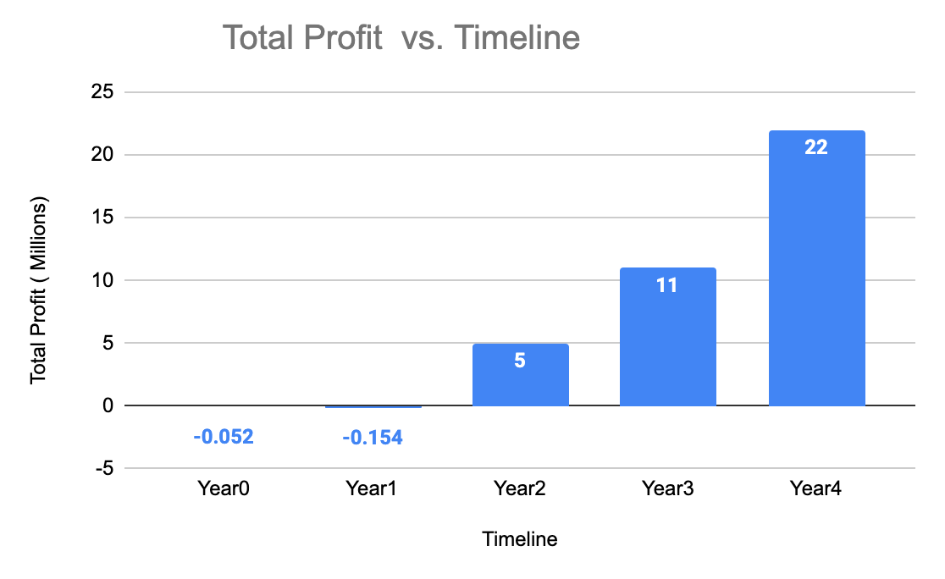

# ADDITIONAL CONSIDERATIONS

## Remaining Assessments

### Engineering Testing and Evaluation

Several engineering assessments have been completed in the initial stages of the product concept development, however several additional assessments need to be performed during the first year of development in order to fully realize a viable product. A few of the key topics are discussed:

* **High Speed, Low Cost Spectral Data** - the crux of the low cost solution, and the ability to provide a consumer focused product is the utilization of low cost sensors to perform neural network based pollen grain analysis. With several scientific papers justifying the deployment of spectral analysis technology, we must perform extensive development to bring the technology to a scalable form.
* **Imaging Pollen in Air** - Due to time constraints, a constant air flow imaging solution was not realized similar to that developed by Swisens. We will need to develop the appropriate intake air filtration system and high speed camera system to prove the low cost feasibility of this approach. With regard to this, intellectual property assessment must be performed, as is discussed in the business planning section below.
* **Pollen Scout and Base Integration** - development and proving of the wireless communication framework on how the pollen base will upload its information, then processing the localized data using AI, and finally posting the update to the pollen scout in the regional area. While not an overly complicated task, the cost of the cloud computing architecture needs to be completely analyzed in order to ascertain better estimates to prove viability of the business model.
* **Pollen Heat map development** - similar to goals of the pollen scout and base integration, the cloud computing piece will need to take in information, correlate data to locations, interpolate reports and pollen weather predictions, and lastly upload local discrete predictions to customers all while maintaining a level of discretion consistent with best data privacy practices.

### Business Planning

A good basis for Pollen ID has been established within the allergy market. However, through our investigation some additional information needs to be completed on the primary and secondary markets to expand and refine the business model during the first year of product launch.

* **Intellectual Property Assessment** - A majority of the research is based upon white paper analysis which has given the team confidence in the applicability of the chosen technology, however significant work must be put into intellectual property research to ensure the proposed engineering design does not infringe on others’ claims. Our initial search has found that Swisens AG has an applicable patent to the proposed design.
* **Agricultural Market Research** - As identified in our secondary market segment, there appears to be an unserved needs in the agricultural and scientific markets. Pollen analysis has been shown to be an accurate indicator of flowering crop yields, and this information may assist in speculative markets. While ~20% of people have seasonal pollen allergies, 100% of people need a stable food supply all year round.
* **Business Customer, Pharmaceuticals** - pharmaceutical companies stand to gain vital information from the deployment of PollenID, as our services and devices are directly related to allergy planning and can influence human behavior when it comes to utilizing allergy medication. Due to limited time, the team has not had the opportunity to conduct interviews with these companies to gauge their interest in a future partnership or data service agreements.
* **Government Customer** - Several scientific papers have been published linking the increase in global warming to increased pollen counts globally. Synonymous with pollen data predicting crop yield predictions, governments should be interested in the stability of their food supply especially as mankind enters unprecedented and increasingly erratic weather conditions.

## Key Competitor Reaction

We assess that our primary competitor will be Pollen Sense among all those identified. It is likely that our competitors will react to our entrance into the market in one or more of the scenarios discussed below.

**Competitor Customer Pivot**

We assess that Pollen Sense, who already possess a consumer based pollen data service, will counter our position by offering discounted pollen data information via their mobile application. Their angle to consumers will be that they can have access to more accurate information without the need to purchase the equipment. They can do this by increasing the number of pollen sense systems for sale at lower costs or deploying their sensors as a sunk cost, shifting their income focus to customers and away from government and businesses.

At ~$4,000 retail per unit currently, Pollen Sense will need to lower their prices and increase their business customer base to be able to compete with the geographical coverage possible through our Pollen Scout systems. They may be able to offset some of these costs through the incorporation of subscription applications. Coupled with the fact that Pollen Sense sensor deployment has already reached every state, they may be able to claim the market by double or tripling their sensors.

PollenID will need to react by providing an irreplaceable home based solution, which offers a significantly cost competitive advantage for the early adopters wishing to have the power of PollenSense application, but cannot attain the hardware at a reasonable cost.

**Competitor Advertisement Campaign**

Pollen Sense along with the other highly scientific competitors will attack the accuracy of the PollenID system since the Pollen Scout uses AI to classify and count pollen through extrapolating signatures from lower tech sensors; the accuracy of the prediction model can be called into question. The competitor may lean on their pollen collection devices with several years of field use that use more direct AI counting methods as a way to separate their product from PollenID and tout the device accuracy (which are >80%) as far superior. In addition, competitor products provide additional metrics beyond just pollen, to include dust/particulate and even mold spore counting to supplement their product offering.

To combat these reactions from Pollen Sense, PollenID will need to focus on the next version of the Pollen Scout, with higher fidelity imaging systems at lower costs and if permitted, add the additional functionality such as PM2.5 and mold spore analysis. Additionally, PollenID will need to continue to grow the size of their Scout footprint to gather more localized pollen data than any other competitor. PollenID will have an advantage early in capturing allergy suffering consumers as there is no current competition, and we assess that once a customer purchases the device, they will be less likely to change course in a short timeframe. We feel the best steps to take to reactions from competitors is to increase sensor fidelity, continue to train and deploy our AI model, and push for large consumer adoption early.

**Competitor Consumer Product Pivot**

The advanced unit technical specifications for the Pollen Base are highly dependent upon the reverse engineering and cost reduction of the Swisens Poleno Mars operating principles. The market reaction from Swisens could be the pivot from medium to low cost devices. Since the competitor already has the technical design and expertise, the comparative time to market would be much shorter.

PollenID will need to combat this competitive advantage through the use of establishing licensing agreements with Swisens, or being prepared to accelerate the Pollen base’s research and design. A capital investment contingency plan should be thoroughly investigated to bring in the right expertise to reduce the time to market window.

# REFERENCES

1. Pollen Monitoring, North Carolina Environmental Quality Website, <https://deq.nc.gov/about/divisions/air-quality/air-quality-monitoring/pollen-monitoring>
2. Miller, Nathan (Environmental Chemist, Pollen Counter). Interview at NCDEQ Pollen Monitoring Laboratory on Reedy Creek Road. Conducted by POLLEN Team (Hale, Deininger, Garg, Mane, Mutuyimana). September 16, 2022.
3. Campbell, Kat (WRAL Meteorologist). Correspondence. Conducted by David Deininger. September 21, 2022.
4. *Pollen Coverage*, WRAL. <https://www.wral.com/pollen/17461433/>
5. Jendayi Jones, Preeti Wagle, Leonard Bielory, Pollen counting samplers trends from 1963-2016, Journal of Allergy and Clinical Immunology, Volume 141, Issue 2, Supplement, 2018, Page AB29, ISSN 0091-6749, https://doi.org/10.1016/j.jaci.2017.12.093.
6. PhD. Debra Fulghum Bruce, Bee Pollen Benefits and Side Effects. October 05, 2021. <https://www.webmd.com/balance/bee-pollen-benefits-and-side-effects>
7. HyperHyve, Honey Analysis Service, <https://www.hyperhyve.com/product-page/honey-analysis-pollen-sources-moisture-content>
8. Fátima Aguilera, Luis Ruiz-Valenzuela, A new aerobiological indicator to optimize the prediction of the olive crop yield in intensive farming areas of southern Spain, Agricultural and Forest Meteorology, Volume 271, 2019, Pages 207-213, ISSN 0168-1923, https://doi.org/10.1016/j.agrformet.2019.03.004.
9. Sipos L, Végh R, Bodor Z, Zaukuu JZ, Hitka G, Bázár G, Kovacs Z. Classification of Bee Pollen and Prediction of Sensory and Colorimetric Attributes-A Sensometric Fusion Approach by e-Nose, e-Tongue and NIR. Sensors (Basel). 2020 Nov 26;20(23):6768. doi: 10.3390/s20236768. PMID: 33256130; PMCID: PMC7730699.
10. “Honey.” Bee Health Collective, <https://beehealthcollective.org/honey-dashboard>
11. *N*HB testing faqs - National Honey Board. (n.d.), from <https://honey.com/images/files/NHB-Honey-Testing-FAQs.pdf>
12. “Pollen Allergies Market – Global Industry Trends and Forecast to 2028.” Databridgemarketresearch.com, <https://www.databridgemarketresearch.com/reports/global-pollen-allergies-market>.
13. “Honey Market Size, Share.” Grandviewresearch.com, <https://www.grandviewresearch.com/industry-analysis/honey-market>
14. Pollen Allergies Market – Global Industry Trends and Forecast to 2028 | Data Bridge Market Research. (n.d.). Www.databridgemarketresearch.com. Retrieved September 22, 2022, from <https://www.databridgemarketresearch.com/reports/global-pollen-allergies-market>
15. “Ragweed Pollen Allergy Treatment Market Size by 2027.” Coherentmarketinsights.com, <https://www.coherentmarketinsights.com/market-insight/ragweed-pollen-allergy-treatment-market-4054>.
16. BioSpace. 2022. Allergy Treatment Market Size Is Expected to Reach USD 31.63 billion by 2029: Industry Share, Size, Trends, Demand, Revenue and Key Players | BioSpace. <https://www.biospace.com/article/allergy-treatment-market-size-is-expected-to-reach-usd-31-63-billion-by-2029-industry-share-size-trends-demand-revenue-and-key-players-/#:~:text=Data%20Bridge%20Market%20Research%20analyses,period%20of%202022%20to%202029>.

# Appendix A: Customer Analysis

Figure 2.1 Pollen Survey



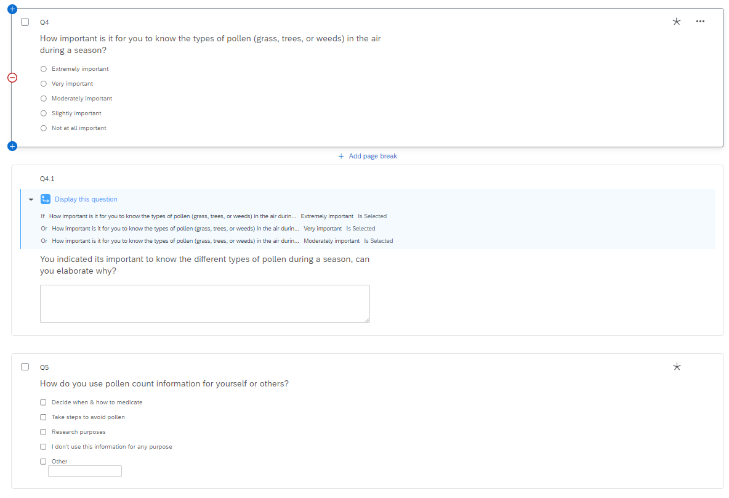

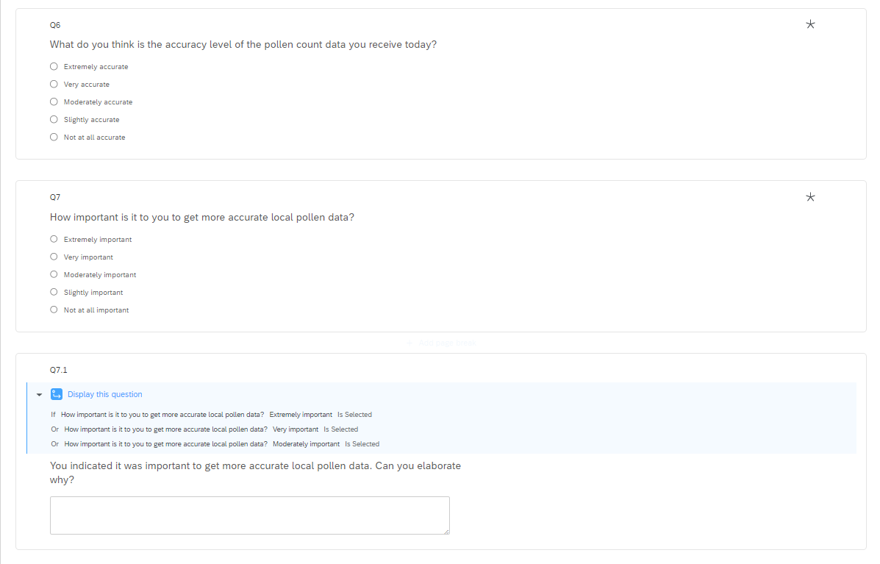

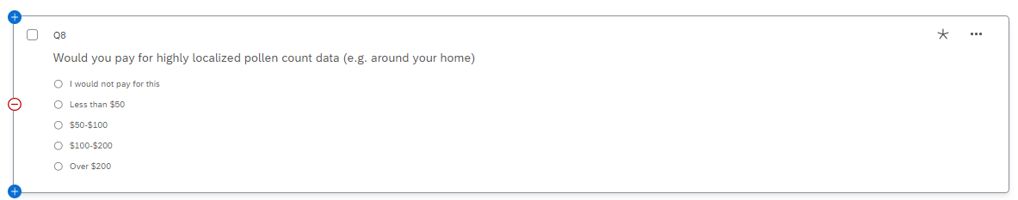

# Appendix B: Business Canvas and Industry Map

